**Phase 18**

You can see design wise , content wise it is so clean and smooth design Some people may get confused that How to bring design idea , How to tell developer what type of design should be there

How to do it we will see

For now understand that How landing page is formed and see the example teacher has told and when you call your developer and guide them then you have good knowledge to communicate with them



Now above is anexample of anpther landing page selling Sofa Upholstery

NOw you can see above we have used Sofa Upholstery and we have shown before and faster

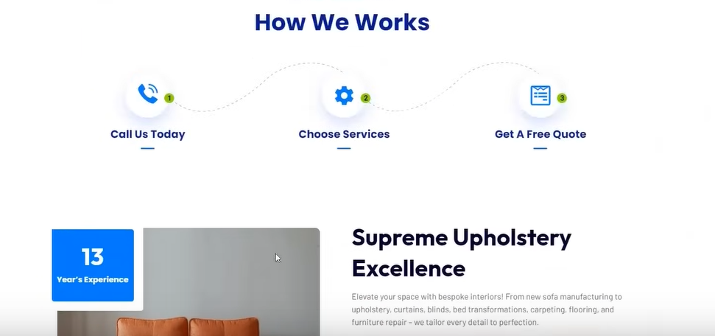

You can see the content is very clean and they have worked with more design



You can see about us

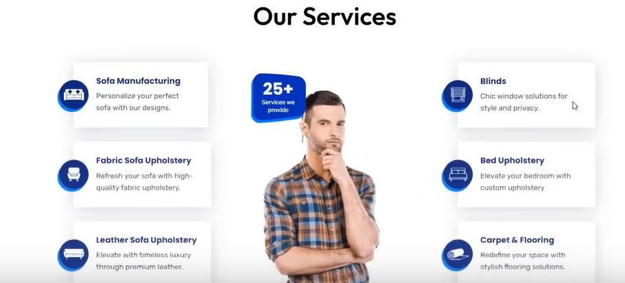

You can see above services and there not in detail and they look very simple It is a winning landing page because the structure the teacher told us is a winning structure

If you follow this then you will definitely make a winning landing page

Like pervious landing page in this page the link navigate in the same way on the same page

Now we will understand that what type of design we want nad from where to pick it and how to twll the developer

Now we go to themeforest.net

It is the website where you get the template and design for websites you buy it here and then upload it

Here you can get design of different services and industry design

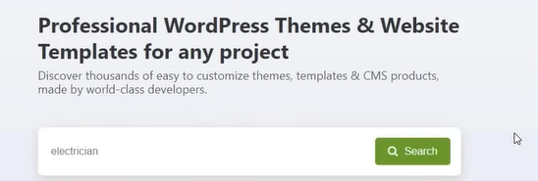

Now we are searching template for electrician website because we want to make website for an electrician

Now you can see different website template as shown below

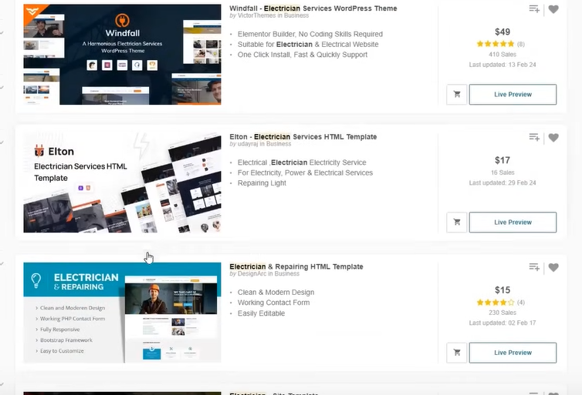

These are the themes

No we click on Live Preview button

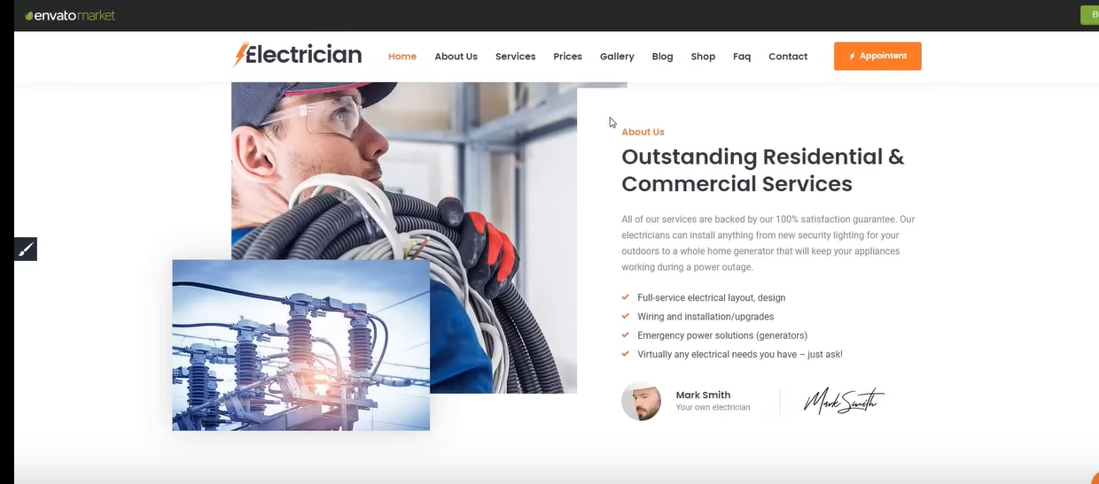

Now you can see there are many things inbuilt there you will take inspiration from it

This section is suitable for us but we will bring a change here abd add a call to action

We need to take ideas from it and pick up good section and tell your developer that I want this type of section

By doing all this you get the idea how our page should look like for google ads

You can get website related to any profession here

One theme can have different demos (maybe its veriant)

Now we are getting ideas that how landing page should look like

You can take its screen shot and gove it to developers that I want this type of sections

Now we have so many ideas that we can tell to the developer Now we have perfect roadmap to communicate with the developer that iwnat what type pof landing page

Normally we are doing this for lead generation but when you talk about ecommerce websites then you need to see something in ecommerce for example if youa re doing checkout then are not questioning them too much it is asking it then remove it and keep it in minimal so that the client can be easily converted second thing you need to see is that your products are being opened properly or not .

What is the speed of your website . We also need ot see is the image of thre product is good or not , you have reviews there or not , you have communicate the pricing or not you need to see this nad then you see is there a problem occurring in purchasing something . If we are purchasing something then is taking too much load time or not , your website load time should be 4 or 5 second, your website should be opened fast , There are website which take 10-15 seconds then your visitor go from there and your visitor does not become a client However he wants your service but your website is so slow that he could not understand anything so he was gone.So this is out landing page understanding which is important that our landing page should be good that when a customer comes then he can understand the service that we are selling what

For example we are selling sofa but in our landing page we rrite in our heading is that we are selling furniture then the client will not be able to understand it

SO we need to educate our visitor make them understand what we are actually selling

WE are telling about what we are selling in ads , headlines and descriptions so he knows what the is clicking on or what he is not clicking on and what thing is coming in front of him

When he will see the header is same as ads then he will be more interested that he has clicked on right website

Normally when you click on a link then another website gets opened(who knows)

S by doing this we remove the tension from the mind of the visitor

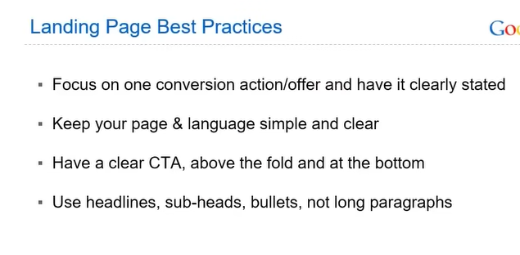

NOw comes the **Landing Page Best Practices**

First point is tht you can focus on maximum two convergence action like form submission and call

Second point is that as shown above

Third point is that your CTA should be repeated so that the customer does not get run away he ca understand that he needs to click there

The fourth point is that long form content does not work in PPC pages or Google ads pages

You need to use more and more headines, sub heads , bullets and not long paragraphs

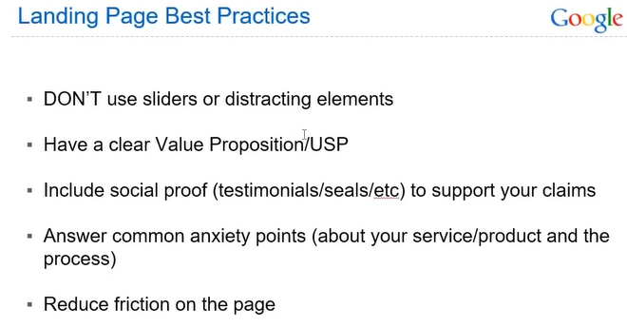

Now 5th point is that Now you have seen that whenever you visit a website than pop up arises there or sliders starts running They could not understand that what is this

If you see the teachers page there is no slider no popup , clear headline ,clear subheadline and call to action SO don’t overdecorate or oversell

Second point is that You have to clearly communicate what you are selling you have to keep telling different benefit and features and give call to action

Third point is that you have to put testimonial in every website and even in lead generation

Fourth point is what we are doing

**Phase 19**

The customer has many question related to you like how long service go on or how long I will get the product

SO you can put the section of FAQ in landing page

In your different section you can answer these anxiety point



You see in teacher landing page in the selected line above teacher is clearing up the pain point

Here he is indirectly answering the question that when installation will happen

We are also indirectly answering that is there any discount

That’s how we need to communicate and answer different anxiety point of the customer

There are many Landing page design tools which will give you pre build landing pages which are as shown below

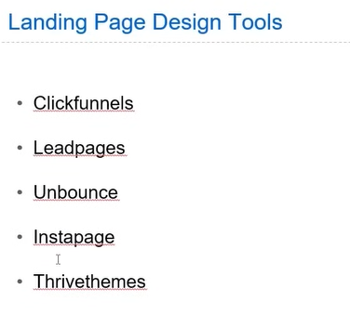

Teacher is recommending toll for lead generation that is Wordpress If you have ecommerce business then use shoppify you don’t have to go outside It is enough they are very good tools

The above are rarely used

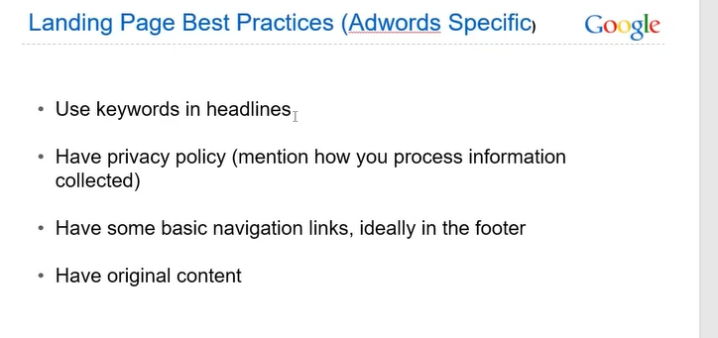

In landing page best practices above points also come

First point is use Keyword in headlines so that you can grab the attention of customer

Second point is that include privacy policy , terms and condition

You can place it in bottom

Normally they get generated by Chatgpt or by privacy policy generator

Give your information then the privacy policy will be generated for you

Thord point is that have some basic navigation links, ideally in the footer

As shown below



The fourth point is that have original content you don’t have to copy it you have to write your own content

Now below is the further best practices

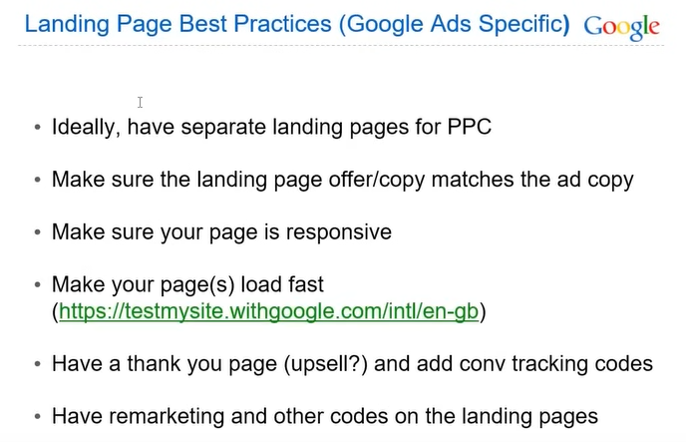

The first point is that Make a separate landing page for Google ads

Because if there is a website in which work is going on then you don’t want it that it get disturbed for that you keep different PPC landing page

You can also add no follow or no index tag(who knows) then it will not interfere then it will not interfere with SEO (who knows)

Second point is that What you are showing in your landing page it should be in your ads or vice versa

So that the customer does not mismatch the things and understand that what he was told in the ad he was getting this thing

Third point is that make sure your page is responsive(means one code working for both mobiles and PC)

Fourth point is that make sure your page loads fast and your speed is good Developers should do your speed optimization

Skip fifth point will study later

Everything works from top till bottom your keyword or landing page is interlinked with each other

If you mistake one thing then all things will be destroyed

SO make sure your landing page is of top quality. The cost of a landing page nowadays according to teacher is 10000 or 12000.

Our next topic will be how to apply conversion tracking. What tools to use we will discuss on it. We will do discussion on it later

**Lesson 9:-**

In this lesson we will learn about **Conversion tracking (Part 1)**

First we will understand what is conversion tracking

By tracking we mean if there is Purchase then how will Google ads will count it as a purchase or how we will count it as a revenue because there is option in Google then there is concept of Conversion Tracking

Or if there is form submission in your website or the person is signing up in your website tehn in Google ads how we will track it

Here conversion tracking is set up which link our website or Google account Whatever conversion is being performed its data go to the Google through a third party tool(who knows) in your Google ads account There are many tools for it but we will use Google tool that is Google tag manager which is very famous tool and we will do tracking through it . There is a tracking tool in Google ads it is very basic tool

We need a advanced tool W want that whatever purchase happened its value should be shown to us that how much revenue is coming to us from that particular purchase

Or if there is a form submission then specific typoe of form or button we can track it these things come in advance

SO track dvance the google tracking tool is useless We need Google tag manager

First we understand there are two type of conversion that is microconversion or Macroconversion

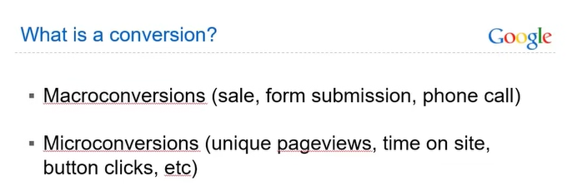

Microconversion is basically lkke purchase , form submission or you get a call then this is MAcroconversion whatever adding vlue to your business

Microconversion have no direct benefit like someone view your page or click on the button or he spend some time in the website

It is called micro because it indirectly benefit you until this does not happen there will be no direct microconversion because when the user first interact with the website or landing page and then he will do the conversion

SO we can call Macroconversion primary conversion

And Microconversion secondary conversion

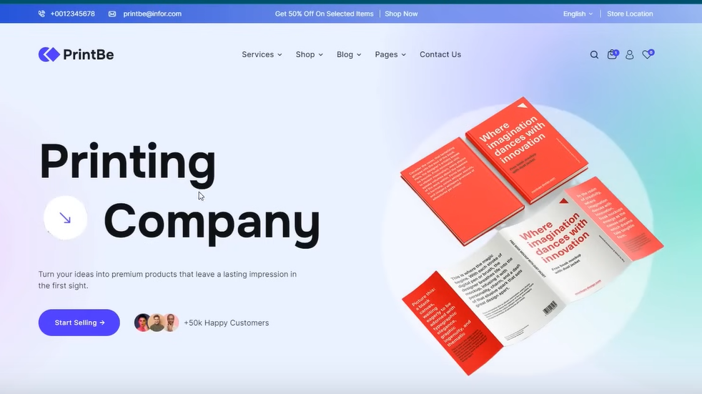

Now aove is teacher test website where we will set up tracking

Like is if someone click on Start Telling then we have data in Google Ads we will learn it

We can track a button click or page load For example some one has reached thank you page Order received page hten we can copy that link and cana lso add tracking there

For example if someone had visited checkout page

For example we go to a cart

**Phase 20**

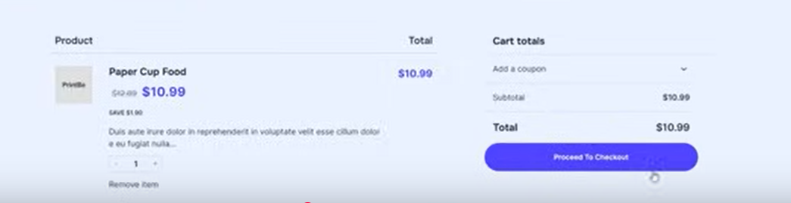

And choose Paper cup food

Now we choose Proceed to checkout

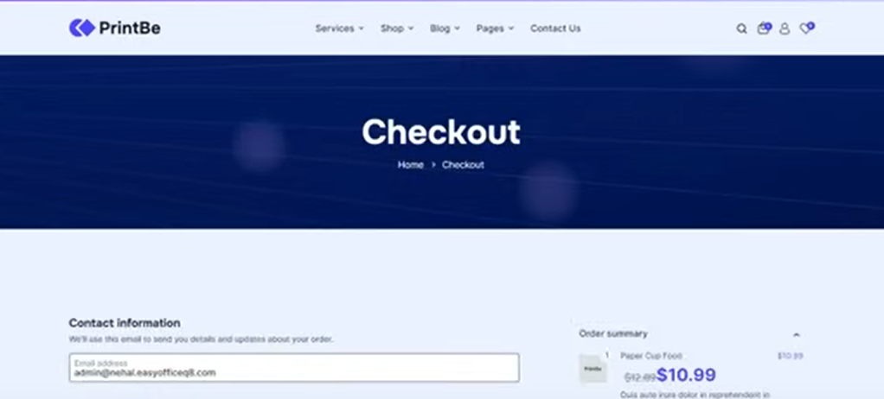Now we reach checkout now we use the url to track your checkout page

Through url we know which page we are tracking now .We can track add to card or any other page like Blog page or contact us page or thank you page We can add tracking to it

Till now Teacher has told us to add tracking on our page

First we will study it and then we will study about ho to track the value or revenue

What exact revenue we need to show in our google ads and we can show exact revenue in the Google ads

We will do it later but for now we will just track the button and page

Now go to Google Tag Manager webite

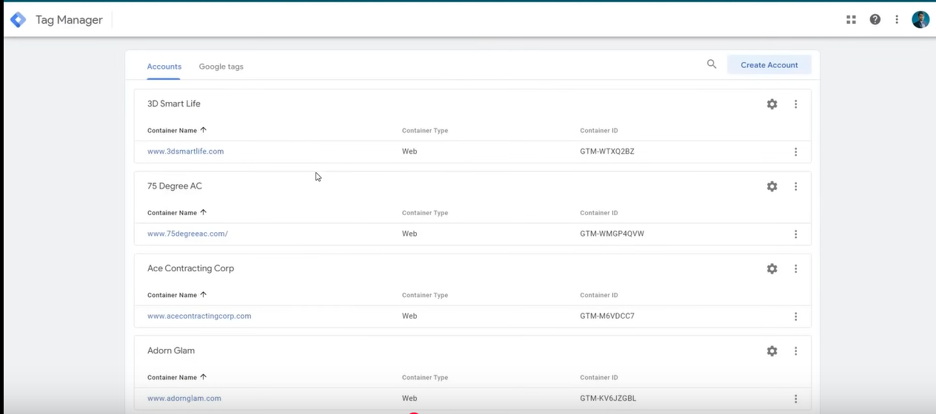

If you have already logged in then you will see the above page

Now all opur accounts will be listed here

I think we can create multiple account here

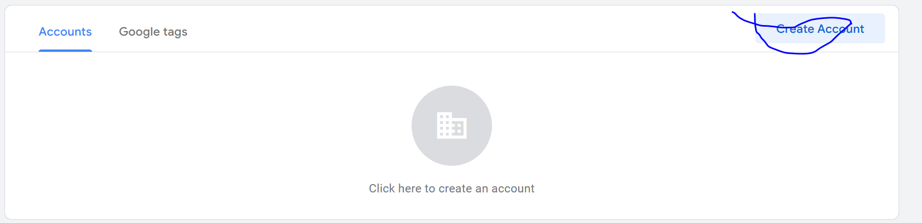

NOw go to Create account as marked above to create an account

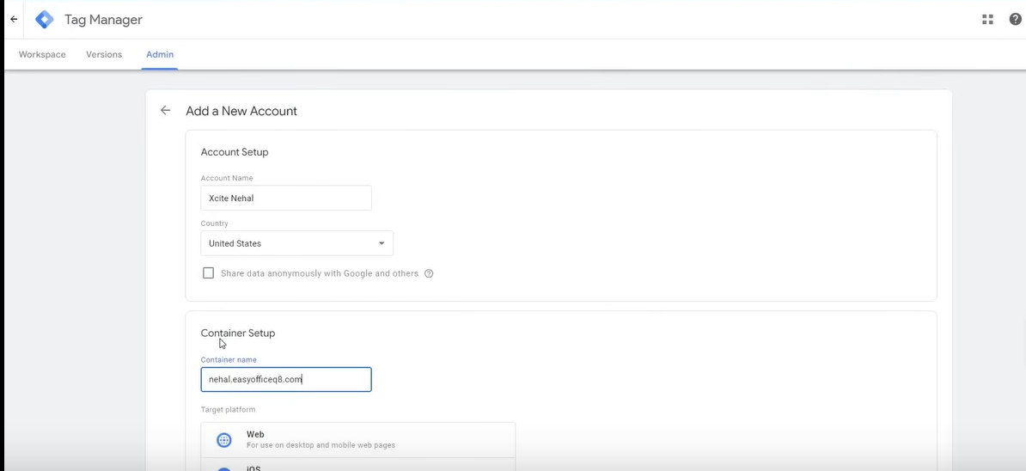

Now above page will be opened Now go to Account name field to tell the account name

You can add company name here

And choose the country

Teacher choosed US

In container setup container name type the address of the website you want to track

Don’t type it in http version but in www format

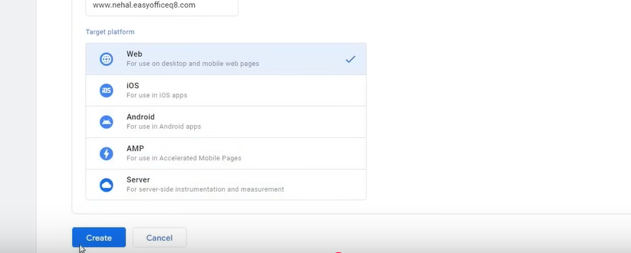

Now choose the Web and then click on Create button

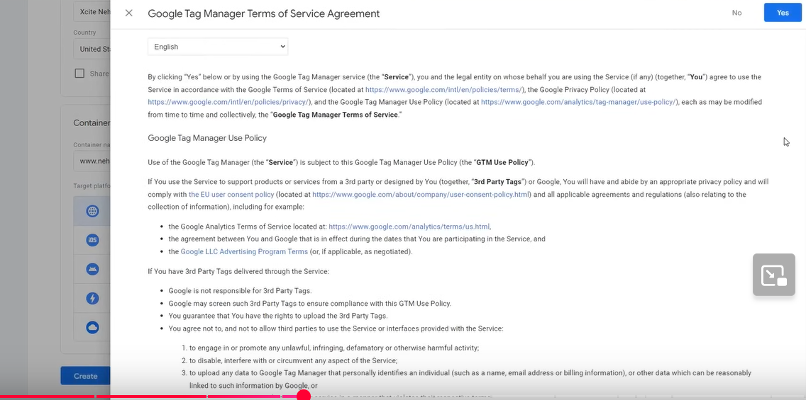

Now accept the Terms and Condition and then click on yes button

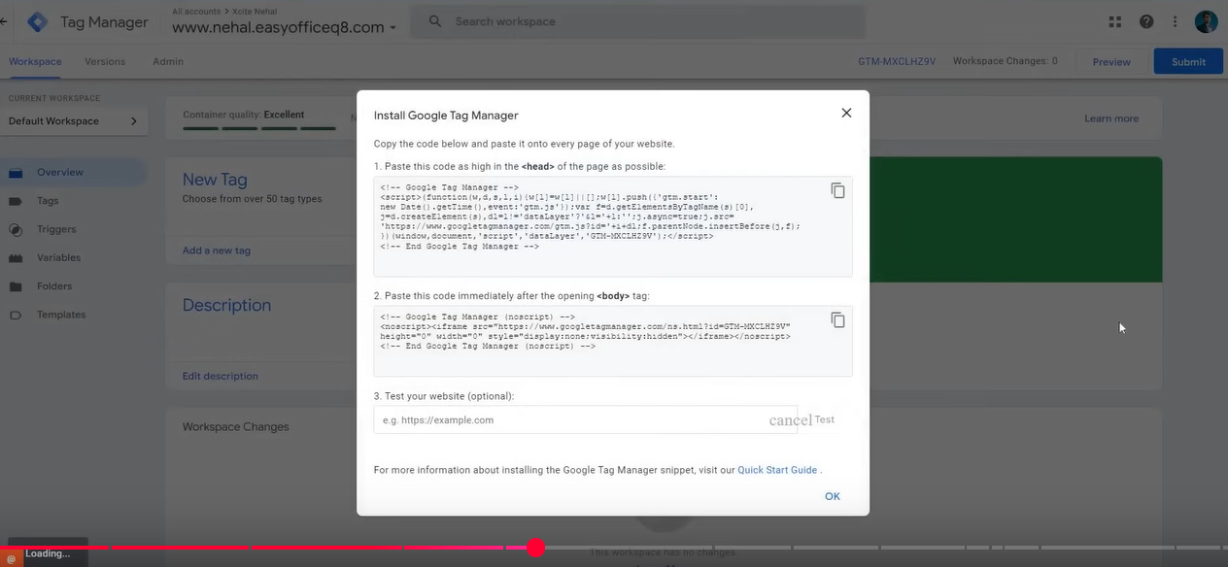

Now our google tag manager is opened

Now from this account we need to install the code in our website

Because anyone can make website on my name but the account will not be functional and your account is trash unless there is code present in your website

So unless the code you see in pop up as shown above is not present in the correct position in your website

Teacher is going to install this code in our website in the simplest way you don’t have to gain technical knowledge for it

Open your website

If you have wordpress then open worpress

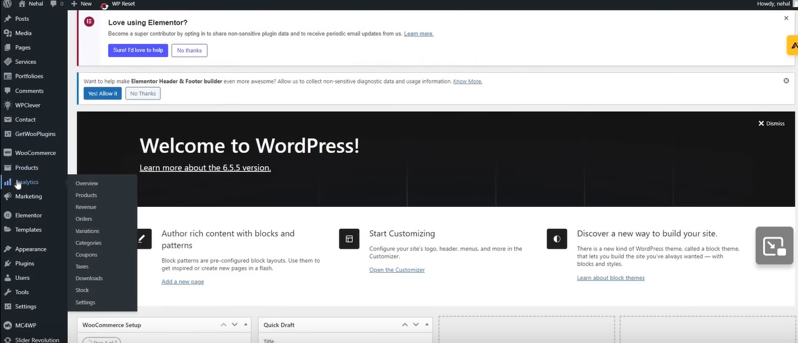

You see these option in every CMS

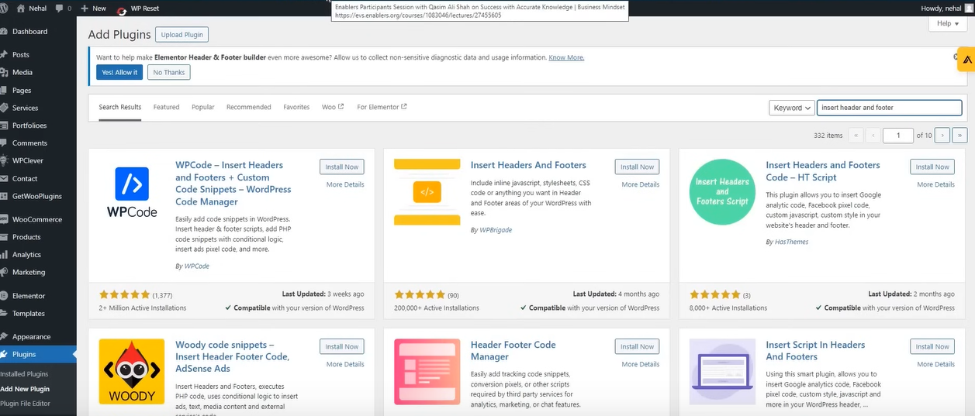Now search about plugin called Install header and Footer

And you can install any one as all plugins have same concept and they perform the same way

The teacher install second one

You have to make sure that the polugin you choose should be updated at most 4 months

Now activate the plugin by clicking on the activate button

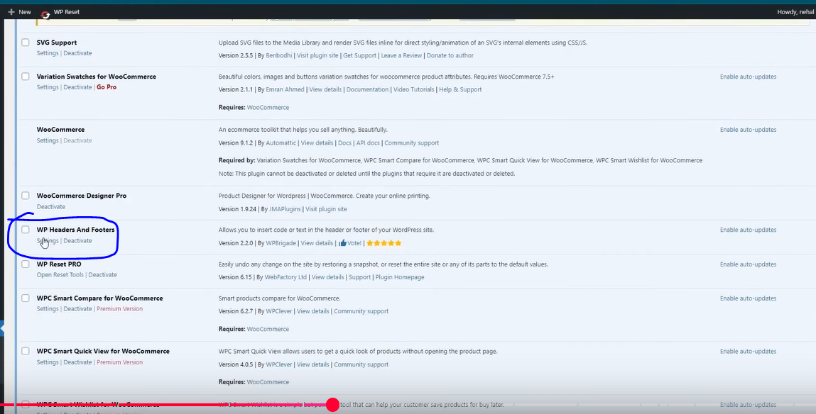

Now in our plugin list as marked above our install and activated plugin is present as marked above Now go to marked above and then click on setting option when you hover over the plugin item in the list

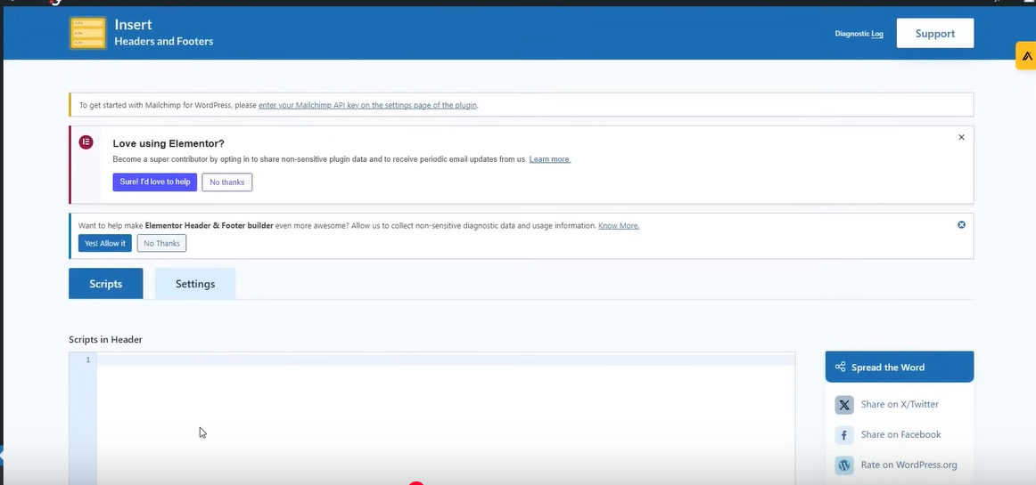

Now above page will be opened

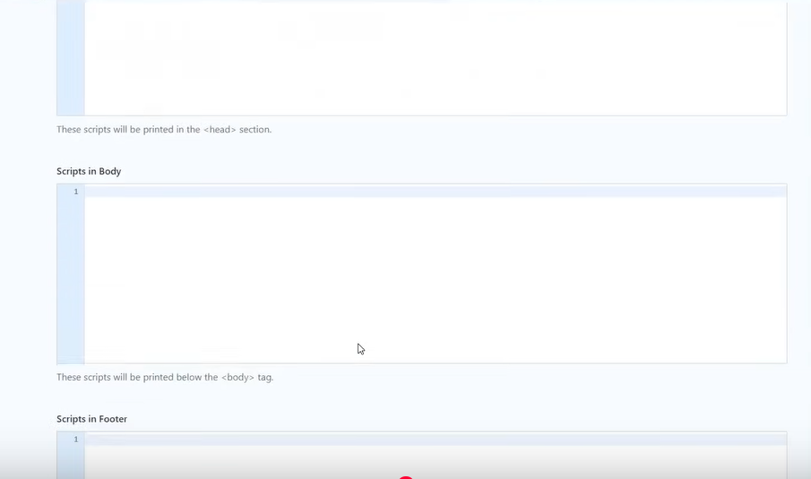

Now these fields represent different section of code where script could be written

GO to Tab og Google tag manager

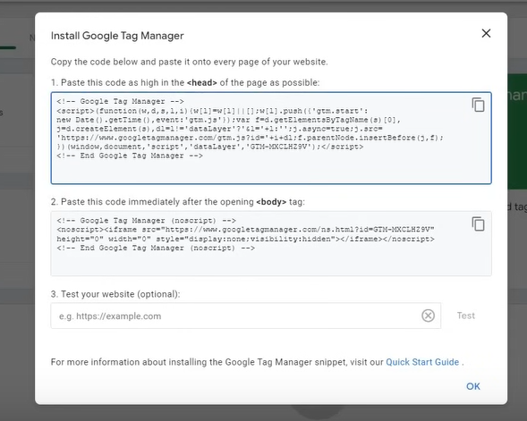

We understand the instruction to what to do Son we do the first instruction

So first instruction is saying that first field is copied and pasted in the head tag

Any technical person will understand it but for people who don’t have can use plugin

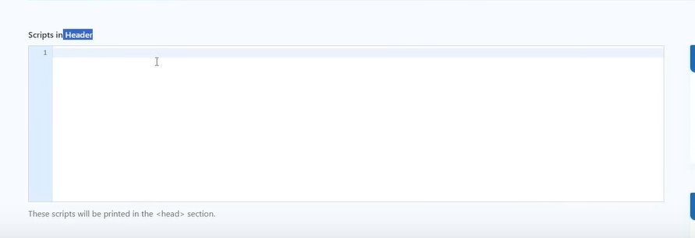

Now copy the code in the first field and then paste it in the Scripts in header field in the plugin setting

Now our code is present in the head

We don’t need to open the coding we just used the plugin and placed it in our header

Now second instruction says that copy and paste this code in immediately after the body tag

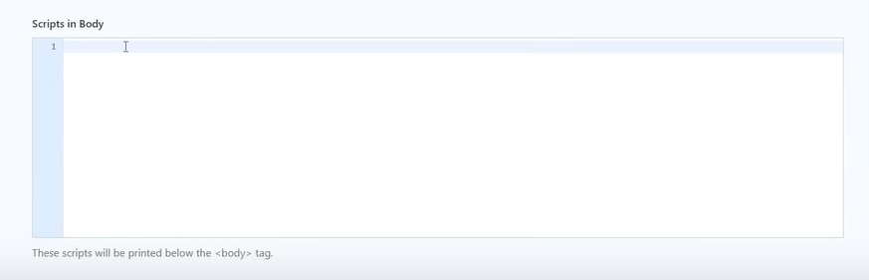

Now we caopy the second field into Script in Bosy field as shown above in the installed plugin settings

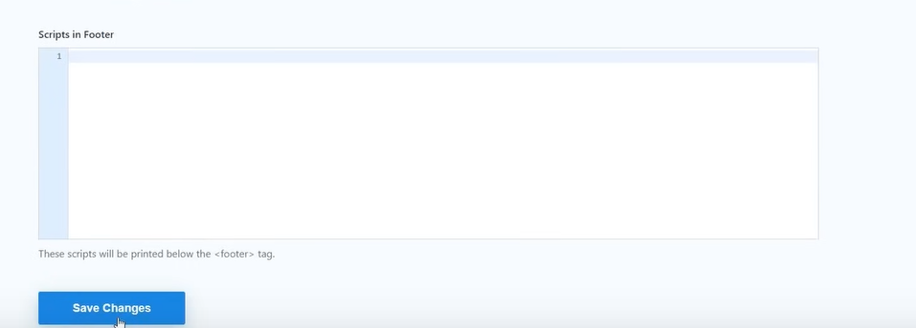

Now we click on Save Changes

Now our Google tag manager is installed here

Now we test it .To test it we use an extension

That is Google Tag assistance legacy

Now search it in Google chrome

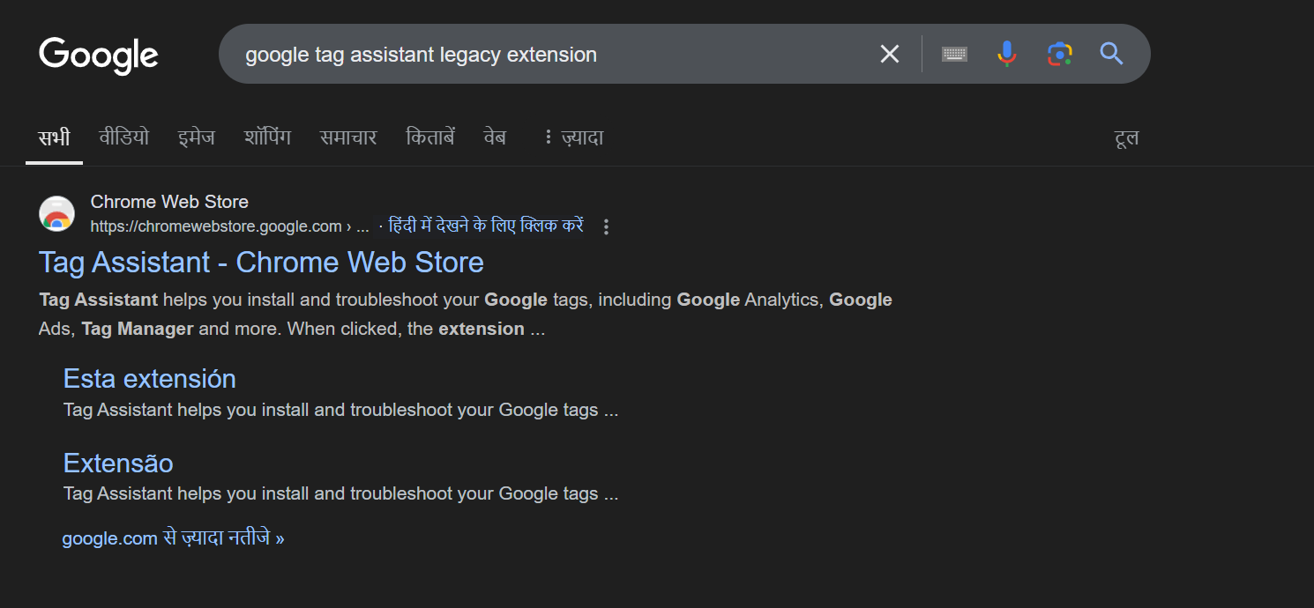

You will get screen as shown above Now click on the first link

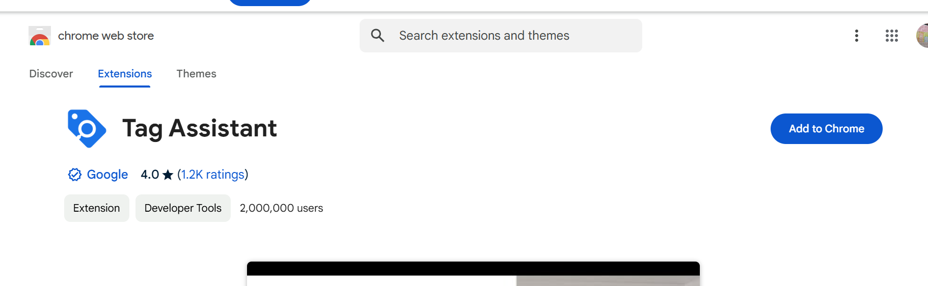

Now click on Add to Chrome button

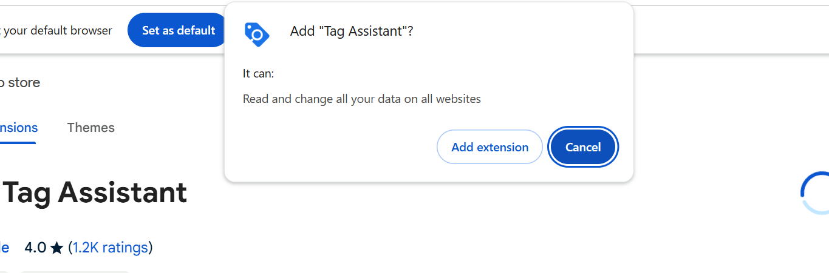

Now a popup appears click on Add Extension button

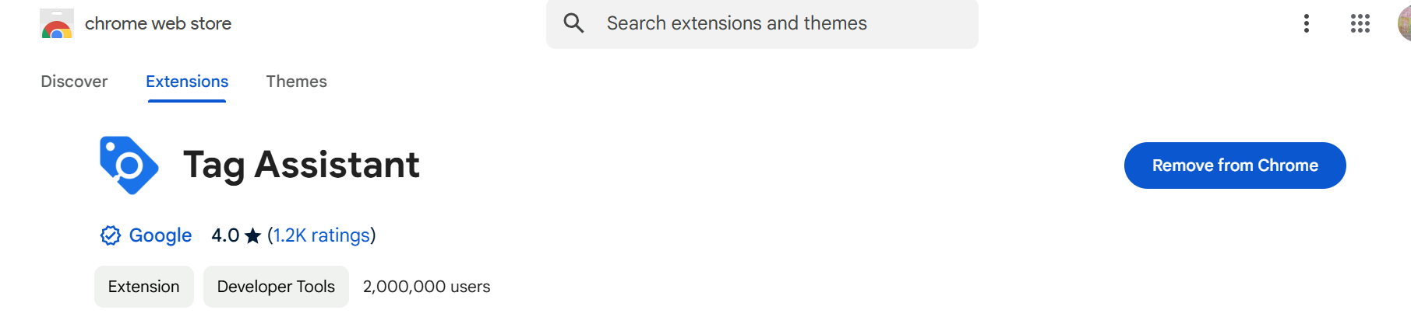

Now our google assistant is installed

Now Through this we check whether the code is installed in our website or not

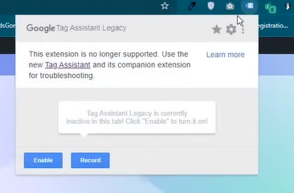

Now click on Enable button if the extension is depreciated then you will see the above pop up now click on Enable to enable the deprecated extension

After enabling reload our page

After the page gets reloaded

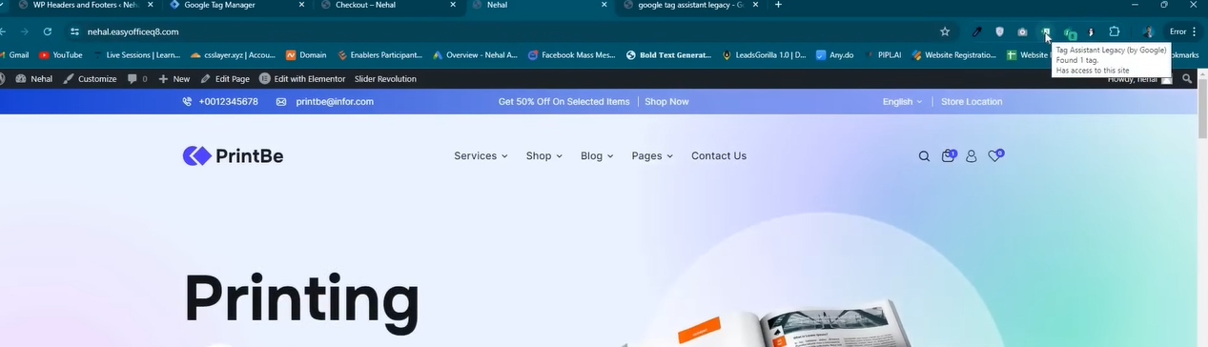

Go to the extension in the menubar and click on it as where is pointer click on it to open it

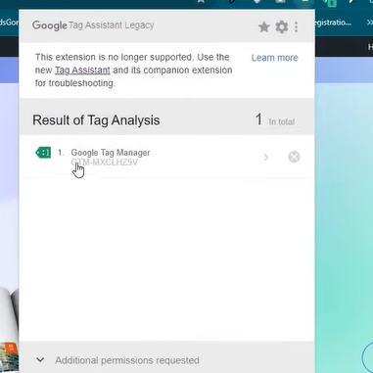

Now in our extension you can see it detected Google Tag Manager code in it . It means our code is installed in our website and in it perfectly working

Second way is in the popup of the Google tag manager as marked below

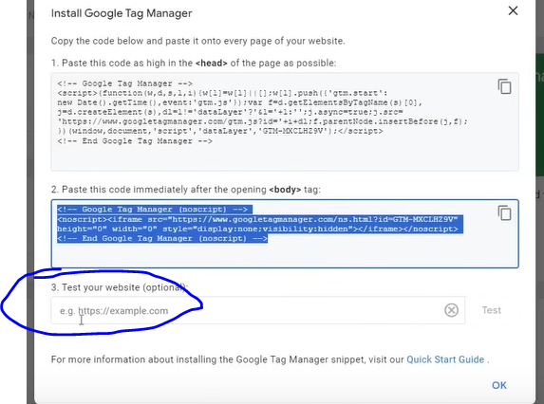

Now our

Sometimes it work and sometimes it not so paste the url of the webstte in the marked above field

And then click on Test button

Smetime it says code is working and sometimes it say not working

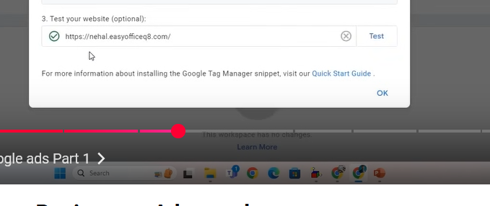

In above it say it works after testing

Click on OK button

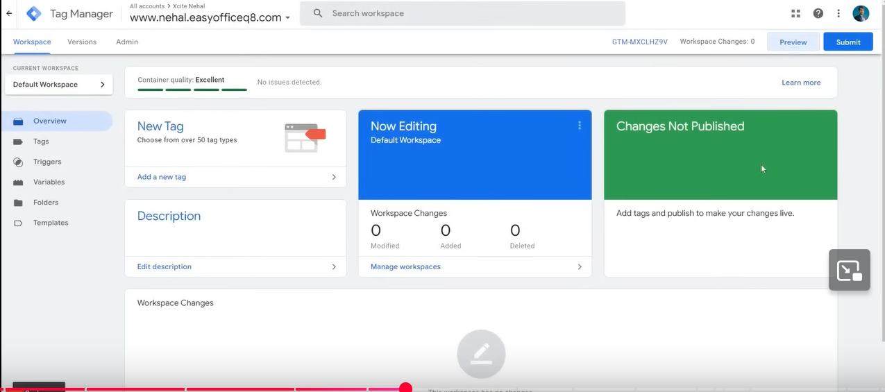

Now above page will be visible

The third way is by clicking on the preview button

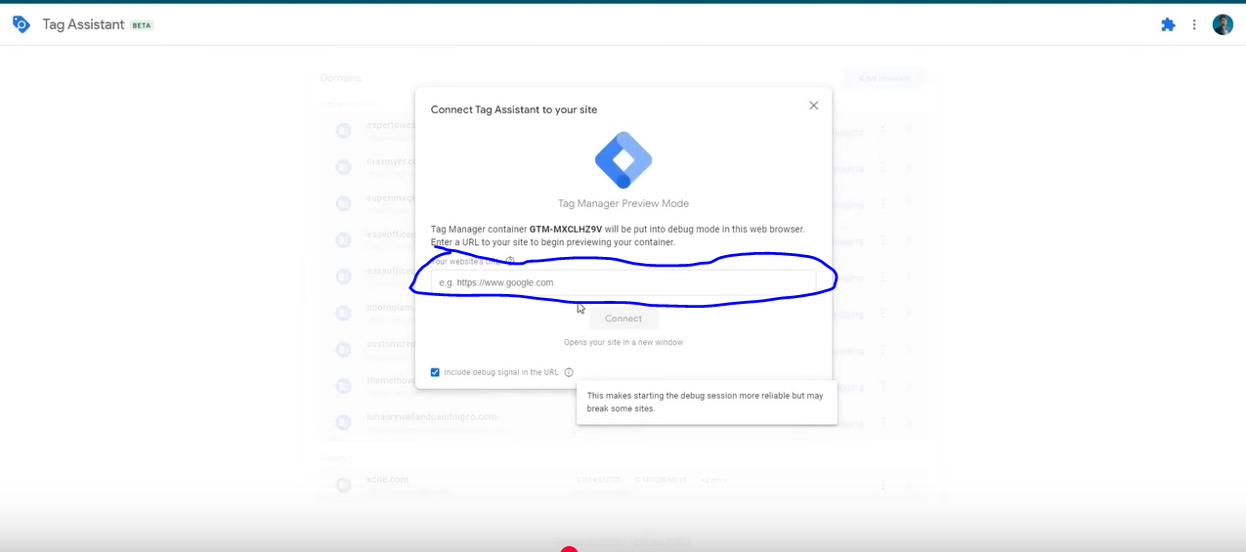

Now above page will be opened

Now copy your website url in the marked above field and then click on Connect button

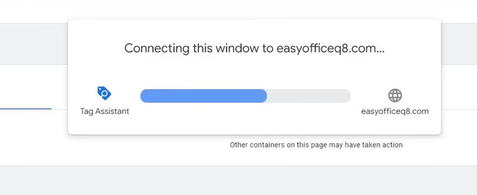

Now it shows above popup as shown above

If it gets connected then it means it is working fine and below page will be shown

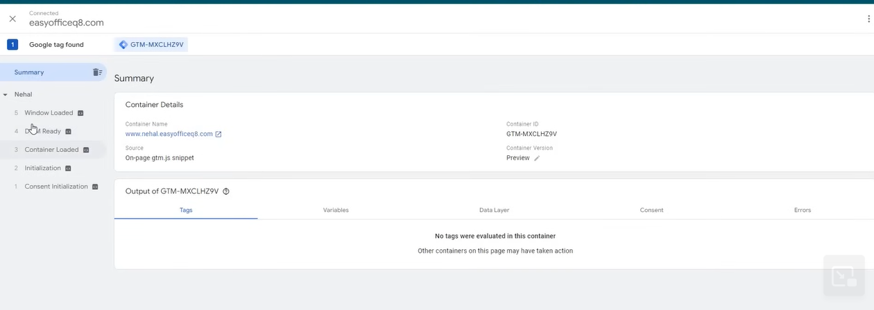

Other wise it will say Google Tag manager no found or code not found then it means there is problem here

So lets see if we open another website which does not have a tag manager then we will see what it will it give error to us

**Phase 21**

So we get

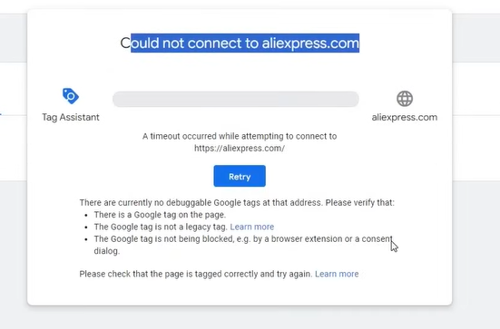

above we tried to connect to a website who don’t have tag manager if there is then it is not properly installed So it will above eoor in our prompt that is Could not Connect to aliexpress.com

Now in our Google Tag Manager we have installed it and added code to our website

And Now I is being connected in the website and we have also linked it

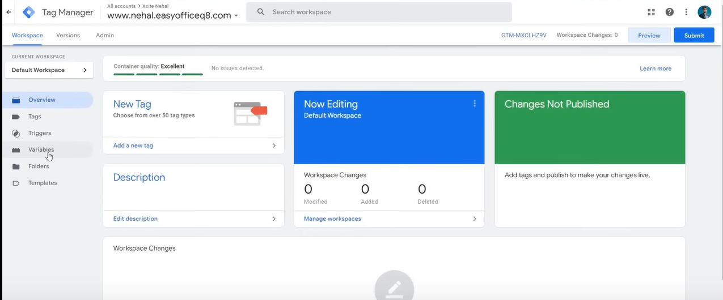

After coming to Google tag manager go to variables in side menu as shown above

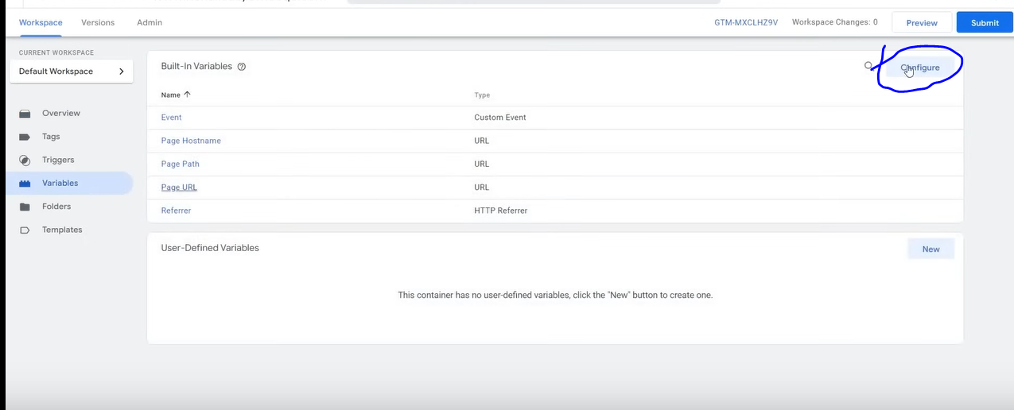

Now go to configure button as marked above

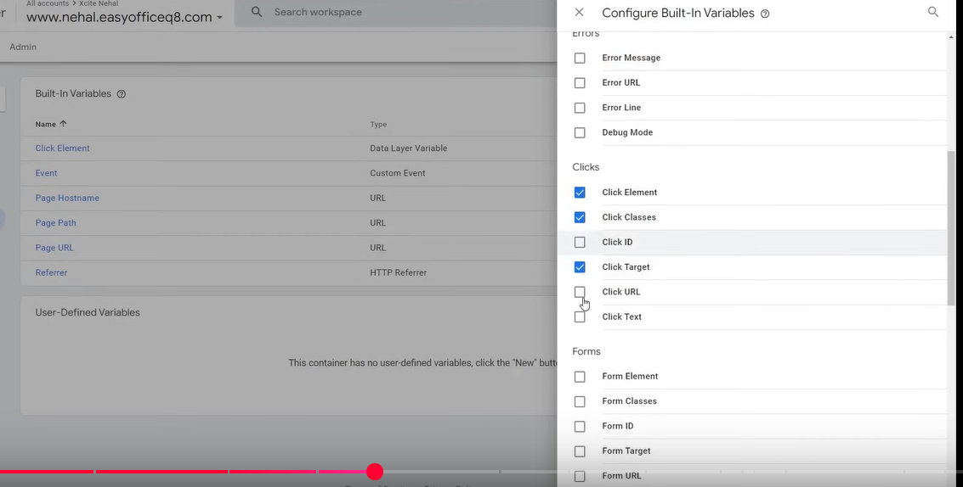

And now here check all the checkbox related to the Clicks a shown above

It is so that whenever we click on something then we can get its classes , id and the element that was clicked and all these checked variables will be shown to us that what is this triggering (who knows)

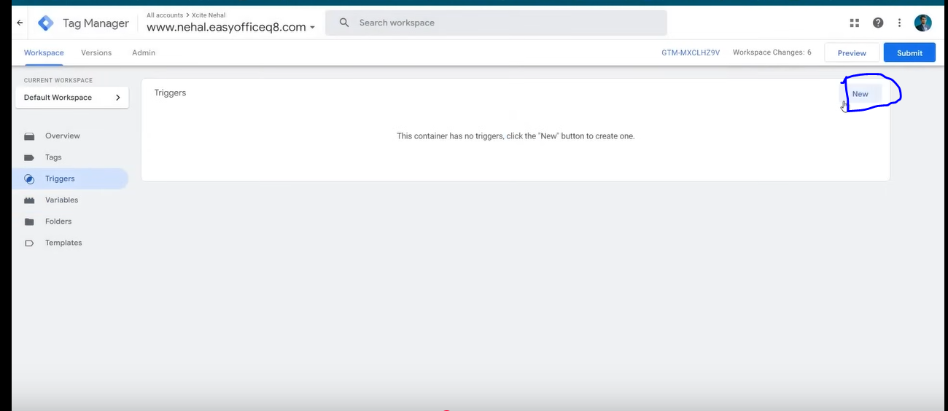

Now go to trigger and then click on new button as marked above

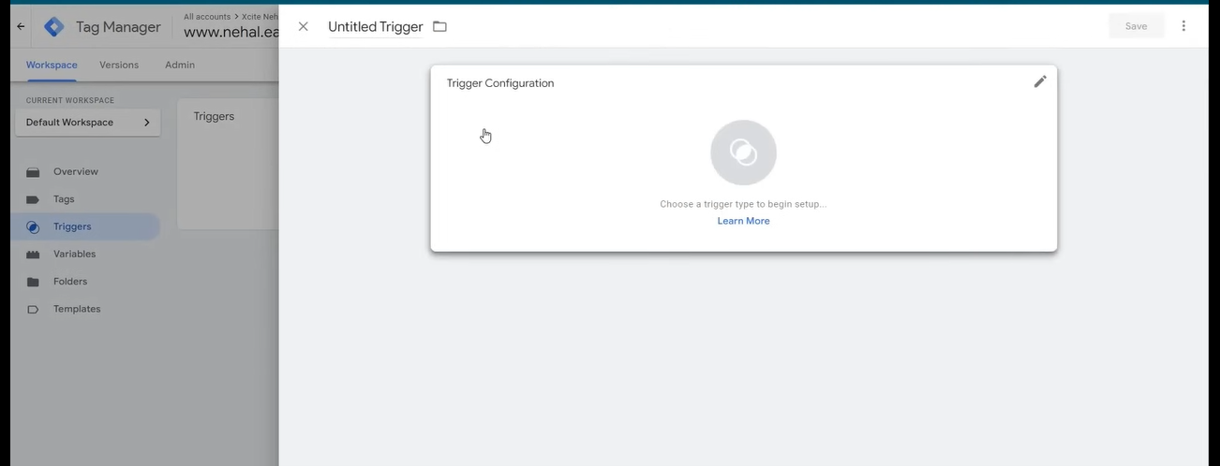

Now click on the box of trigger configuration

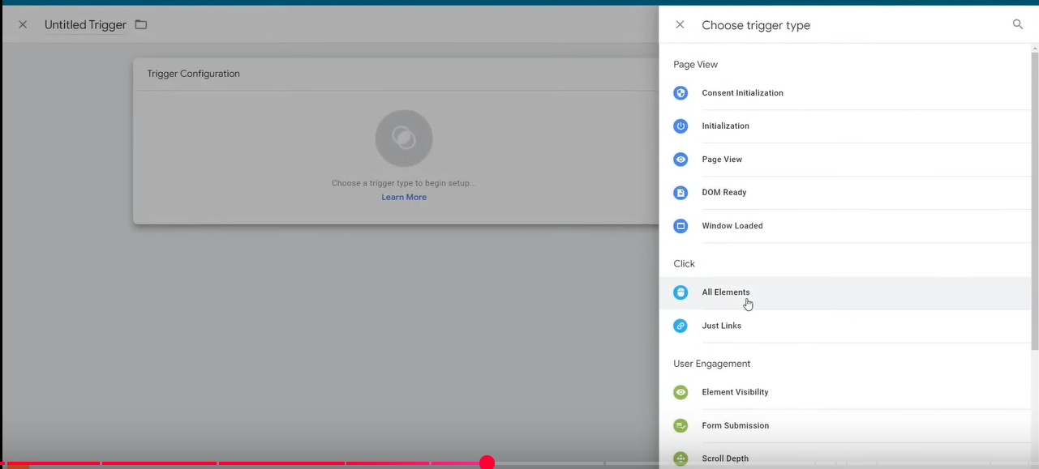

Click on All Elements sidemenu

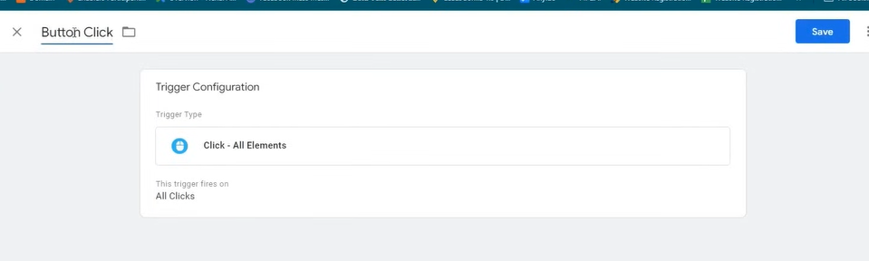

Now it will look like above

We have done it so that we can kow what click triggering what variable

We name it Button Click

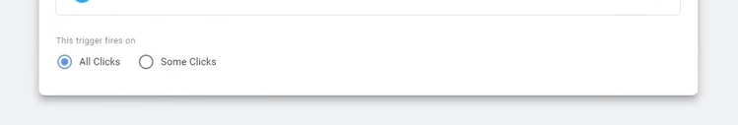

We choose All click because we can monitor all the clicks and see by what click we get what data

Now click on Save button

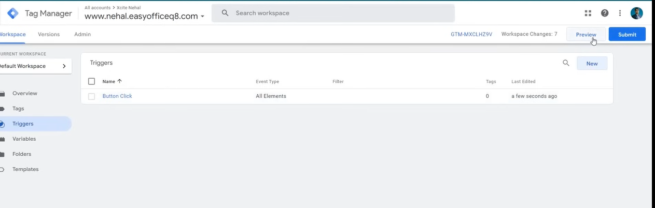

Now trigger is listed as shown trigger list as shown below

Now third step is preview

We agaoi connect the website by pasting the website link so that the Google assistant is connected to our site

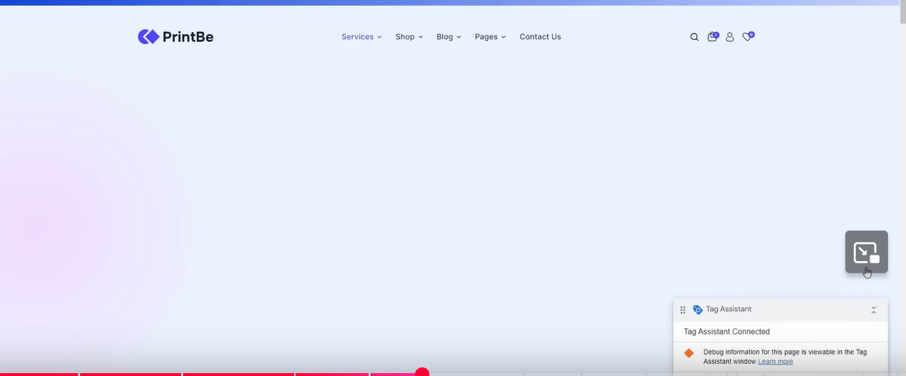

After it get connected you will see the pop up saying that Tag Assistant Connected

Now in trigger we set that whenever some thing is clicked suppose we click on start selling button

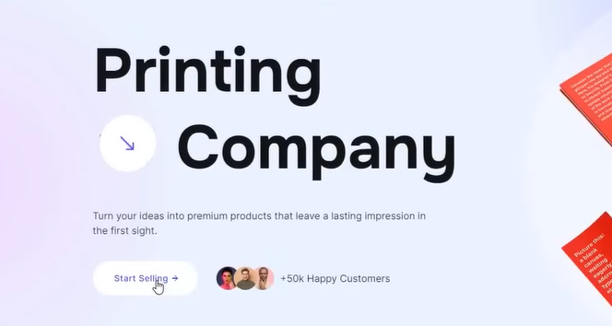

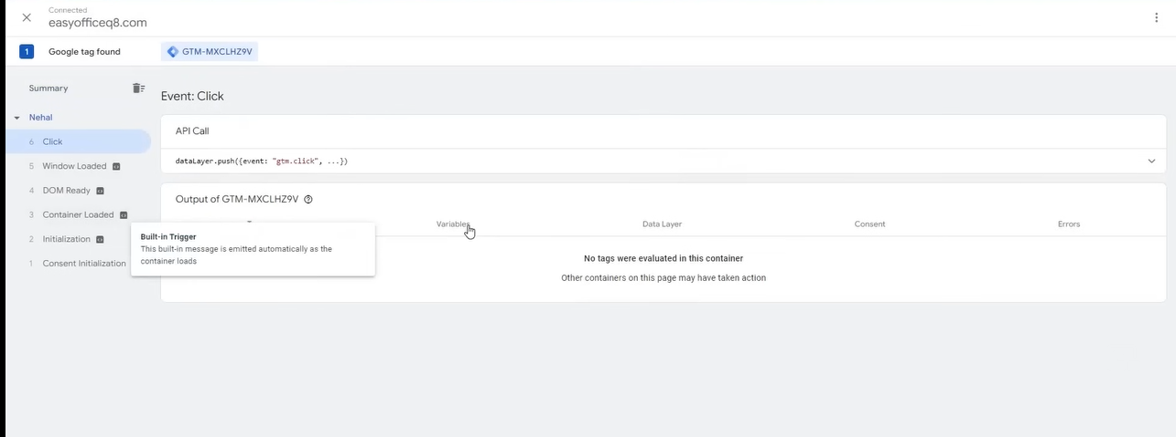

You can now in your screen you can see click information on the side menu

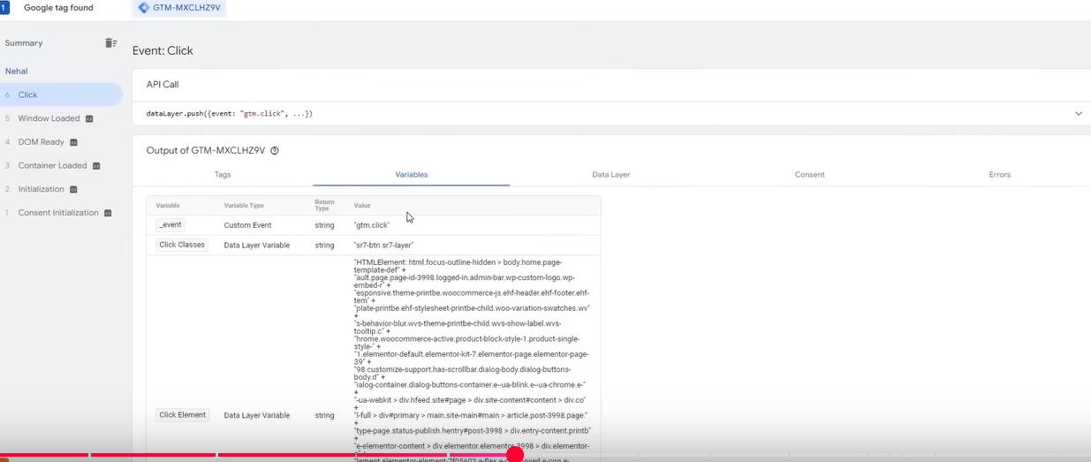

Now click on the variables tab to see the variables that was triggered after click

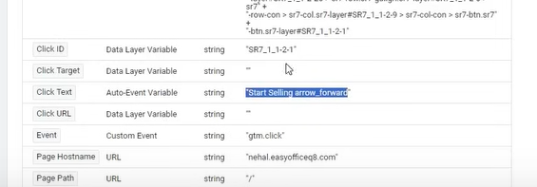

Now in Click text variable you can see that what was written on the button that was clicked

By all these we will know that by which button which variables are being triggered

And by using these variables we will do tracking means we will use this variable to add tracking

Mean we will use that variable as a trigger(I think by that variable we will uniquely identify that element on which click has occured) in our tracking

For example we pickup click classic variable it means we are adding tracking on the Start selling button



Now Suppose we click on Explore more button

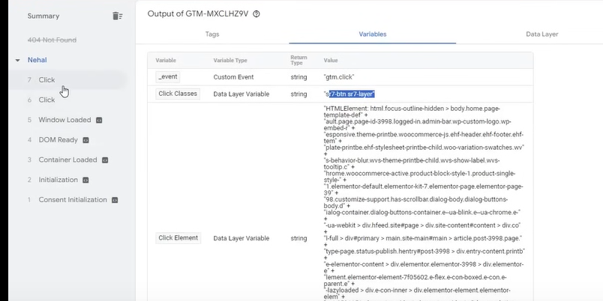

Now you can see there is another click showing in the list

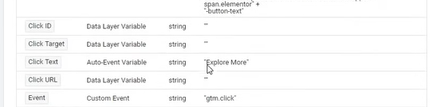

You can see now in Click text it is written “Explore More ”

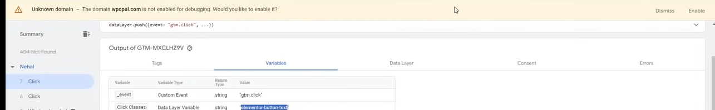

The error you see in yellow color is because we had reached 404 pae due to which it get disconnected after click on Explore more button(whio knows)

Even if we click on any text it will also track it



Now suppose mouse is clicked on the paragraph as shown above

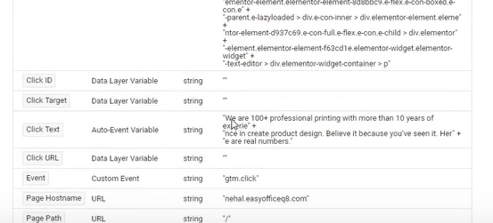

Now it will show a paragraph above in click text

Whatever click we do all data will go there

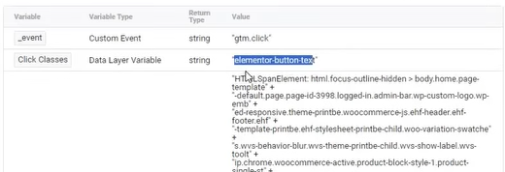

Now thing that need to be seen is that the last button we clicked it was showing same so I think it cannot uniquely identify a click

So avoid tracking through it because due to this you will be tracking buttons you don’t want to track

SO clikc text is good because we are assuming that no two button have same label but different functionality

So using click classes for tracking can be risky you have to check it before using it is there any other thing with same click class that we don’t want to track

Now we start adding tracking

Now we add tracking on start selling

We will track it by Click text

SO now we will go to Triggers sideMenu

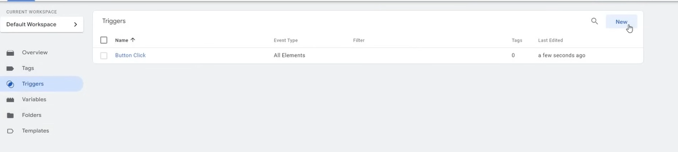

And now go to New button where there is pointer

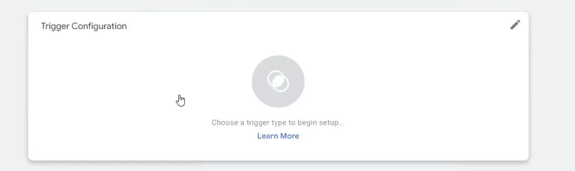

Now click on the block above

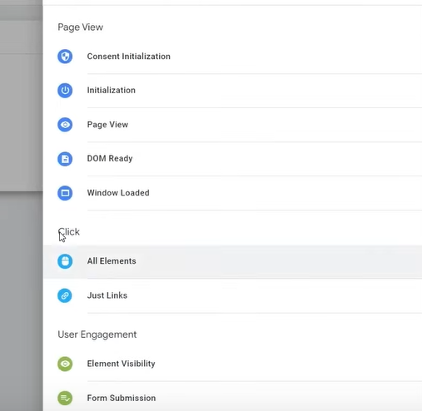

Click on all elements

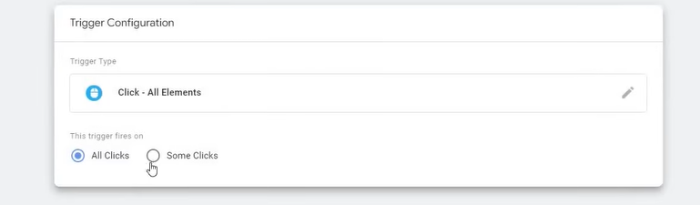

Now we click on some clickradio button

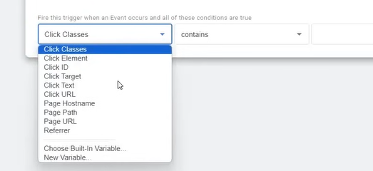

And now in first field choose your variable you want to do tracking

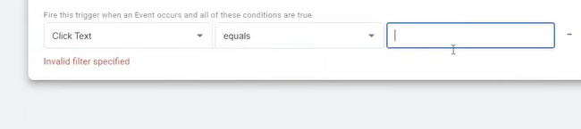

We choose click text .In second field we tell how we want the variable to match with a value, we choose equals now in third field we type the value the variable should have

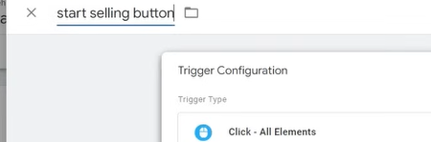

We name it as above

If you want to track a click

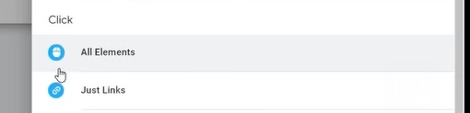

Then always choose All Elements

Now Save it by clicking on Save button

So we have made a trigger which is when there will be click on it Googletag manager will read it if this click text is getting triggered or not If it is then through tag this data will reach google ads

First see triggers then tags

**Phase 22**

Now we will try to track a page now for example contact us page

SO first we reach the Contact us page after reaching to it b navigation menu

Copy the url

Now in triggers click on New and then click the block

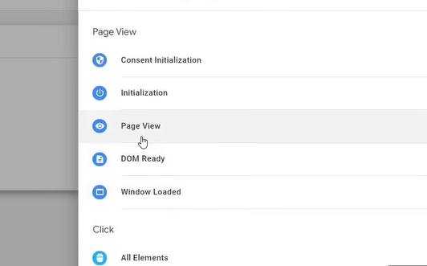

Now we choose Page view because when someone reach that page then there should be tracking

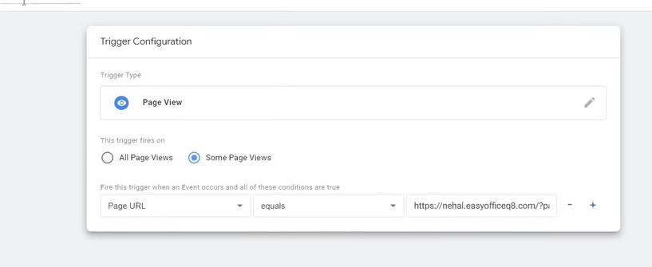

Now choose some page

And now in first field we choose Page Url and then in second field choose equals and in third field paste the url of the page we copied

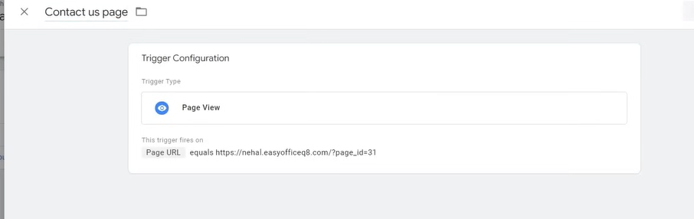

Now we Name it as shown above

Name should be related to the trigger you applied so that if you see it later tehn you can guess what it is used for



Now we want to track the submission of form by tracking the form submission page

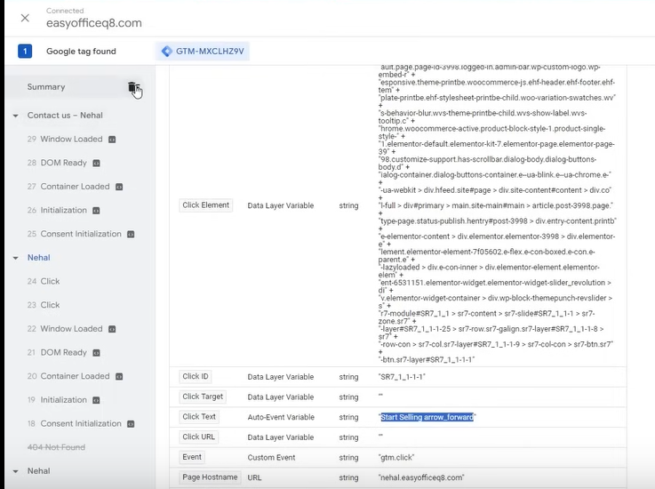

You can now remove the summary where there is pointer

If you think there is too much clustering then you can remove them

Now we click the button send message of the form

Now in our tracking

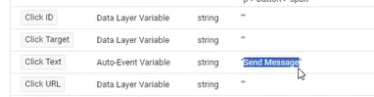

It shows in click text that is Send Message

We just have to copy the data of click text that is Send Message

Now create new trigger and then choose all elemnt

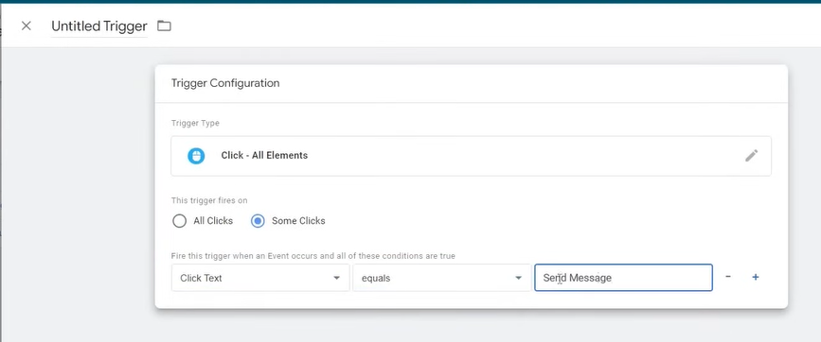

And do above configuration

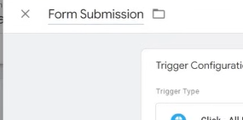

We name it as form submission ‘

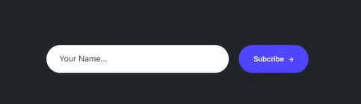

Now we will add tracking to subscribe

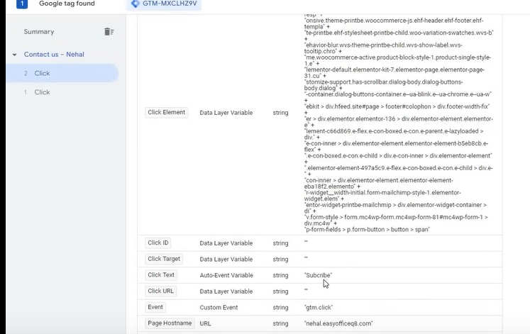

Now you can see after clicking on subscribe button you can see “Subscribe” as value of Click Text as shown above

We will do with it the same like we did with other button as shown below

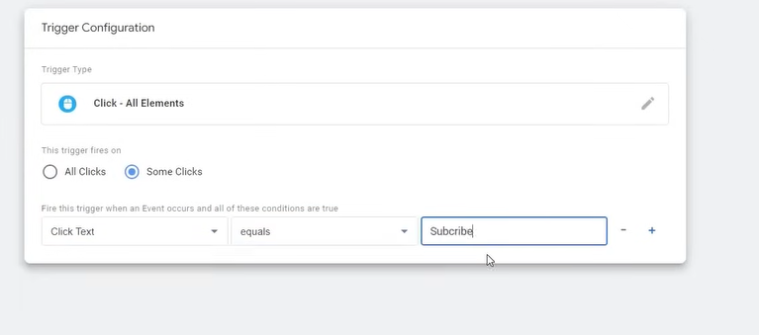

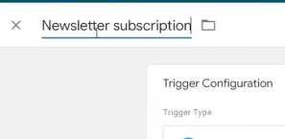

We name it as Newsletter subscription click on Save button

Now we will see an example of how page view so that you can understand how page view works

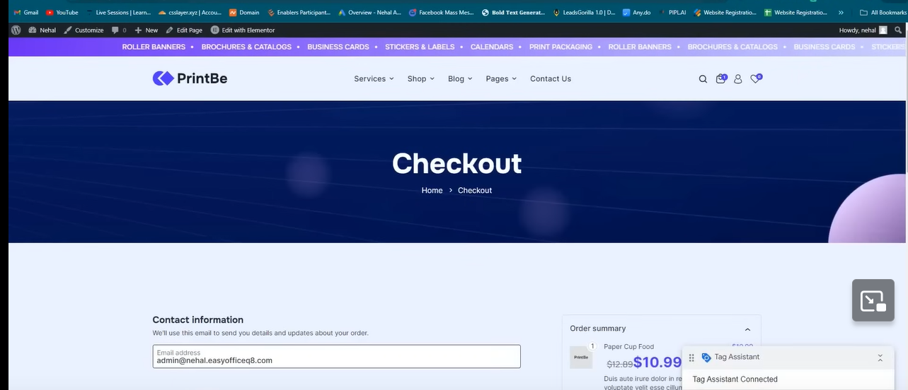

Now we are tracking checkout page

We copy its url

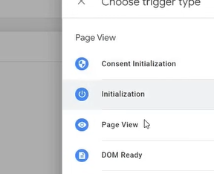

Now we create a trigger with page view configuration

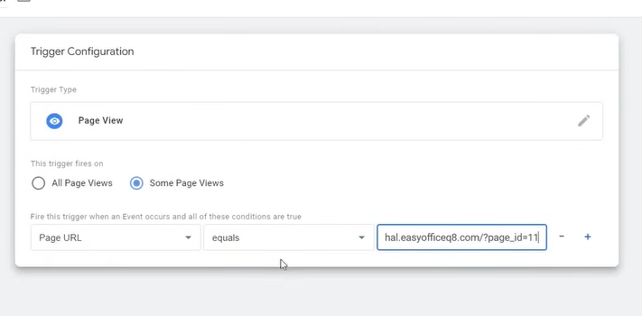

We can also choose page path

Page URL returns almost the entire URL while Page Path returns the value that comes after the hostname (but before the query parameter).

And then in second field contains

And third parameter we take the path come after ? in the url

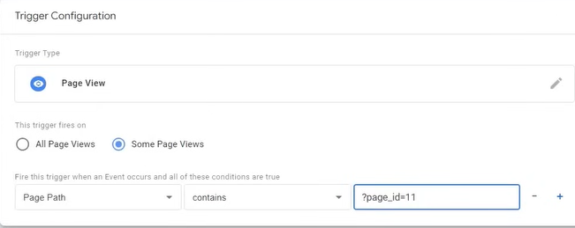

SO you can do above if you cannot track by complete url

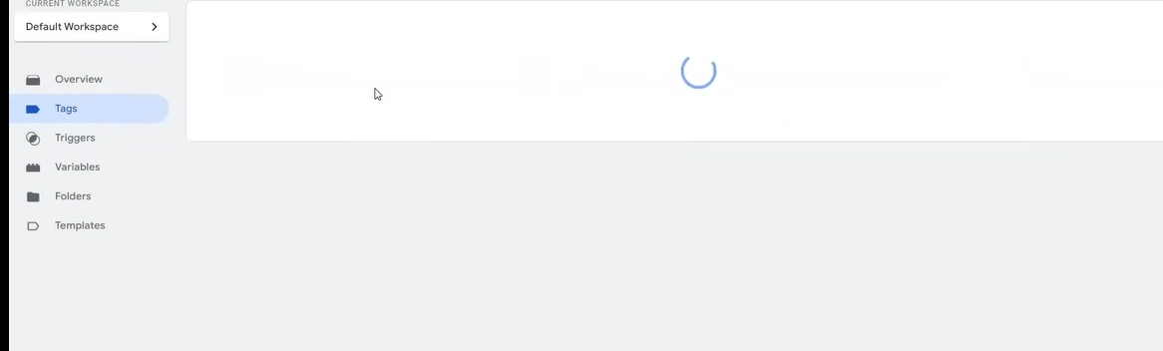

Now we will go to tags sidemenu

Now what are these tags

We did everything we did the tracking of button now we need to connect and it will be connected through tags (I don’t know)

The tag option in Google tag manager is a connection between Google ads and Google tag manager

It is a very difficult topic but you will understand it gradually

Now we will see how to add google ads there

SO we need ot go to google ads because we need to create tag there also

When we crate conversion tracking (maybe tag) then its is or label through which we come to know that we want to bring conversion to this trigger mean we need to do this conversion in this trigger

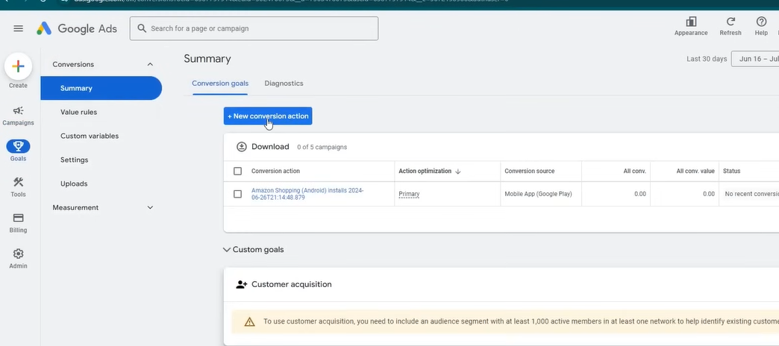

SO now go to goggle ads Then go to Goals> Summary> New Conversion action

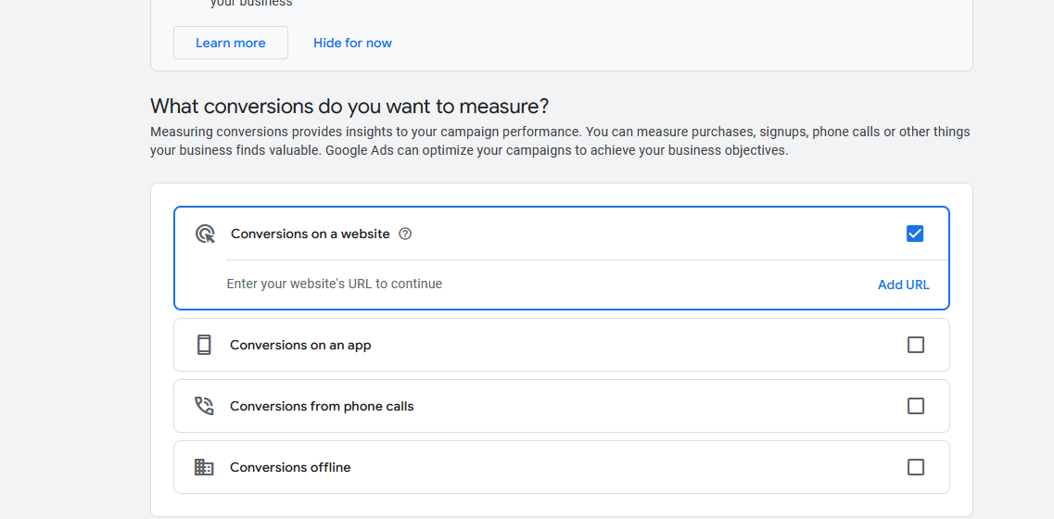

We are tracking the website so we do choose 1st option and then below it click on add url

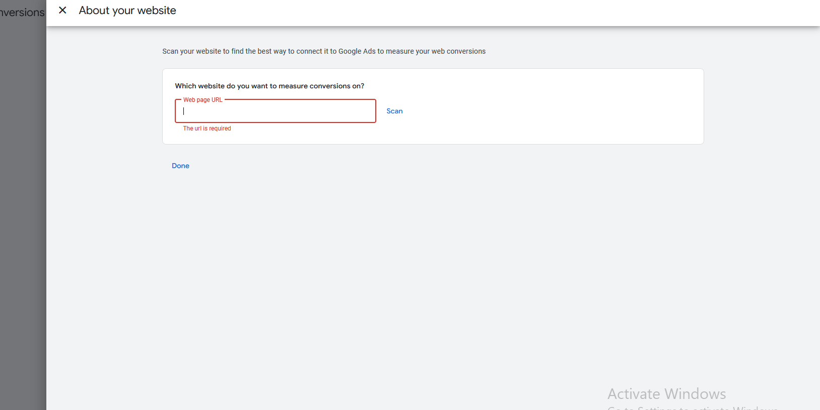

And now tyoe the url of the website that we ant tot track

And now click on scan to check if such website exist or not

It can give us suggestion about what tracking we want to apply because in starting the teacher has said initially that it is a very basic tool and it give very basic function that’s why we do not use it(who knows)

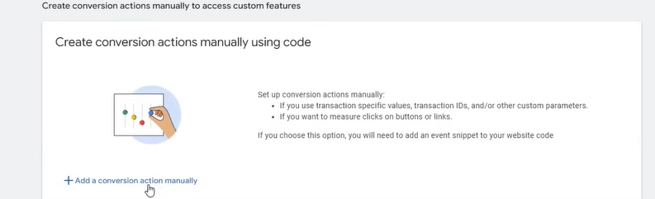

Now click on add a conversion action manually

It can happen you can get other option you don’t have to select it

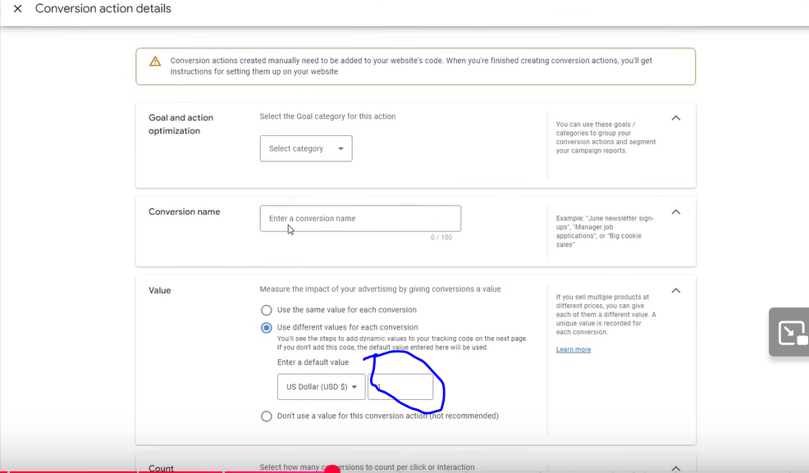

Now in Select Category choose the category you want to give to your conversion according to the work it does

Now we need to target subscription conversion so we choose subscribe

And in conversion we need to type the name of the conversion so that we can easily remember it easily

Now we need to

**Phase 23**

So in your conversion name make suew you also te your name because some conversion action can also be added byb your team so to avoid this confusion do this Make name such that you will remember it easily

Now we come to value section as shown below the conversion name

Now in it there are many option given here

First option that is same value for each conversion we use this option It can be used in lead generation if you are selling a product which have only one price Its value will be tracked

Whenever there is a conversion happens then the value oin conversion value field as marked above then that value will be reflected because our sale happened is of the same cost

Conversion value is another name of revenue

It will be benefitial if in your website all products have same cost then you set there so that you can track but important is that the conversion you are using should be purchase but we have choosen subscribe so it will not work

In second option we can track different values in the website or different priced products in the website like in ecommerce store

Third option is that don’t use a value for this conversion action It is usually not recommended It is used specially in lead generation where form submission is happening or there are calls happening

Since we are using subscribe as a conversion we will choose third option in value section because there is no value we ar getting by subscribe x

Now in count section suppoe if a same person is submitting a form one by one or if he is purchasing same peoduct agaoin and again

If we choose purchase then how many times he is purchasing the same things our value is increasing so we want it to be tracked so for that we choose every

But if a person is repeatedky filling the form or calling then we will not choose every but one

So for lead generation we choose one and for ecommerce we choose every

This fact is even mentioned below them indirectly

IN lead generation hoe many times one person interact with us the lead will not get multiplied automatically and its value will not be multiplied but I purchase the value is increasing

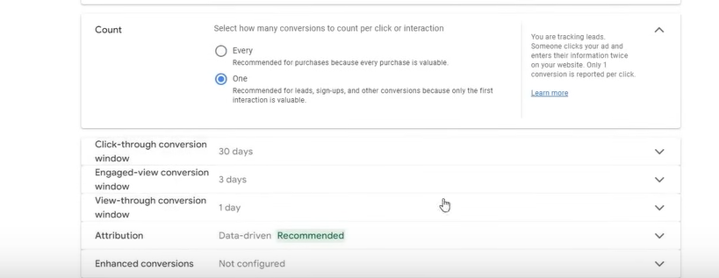

Keep the below function as default w e don’t change it because they are set by Google

In attribution we mean our credit should be given to what conversion if there is multiple conversion (who knows)

Leave it as it is

Click on done button

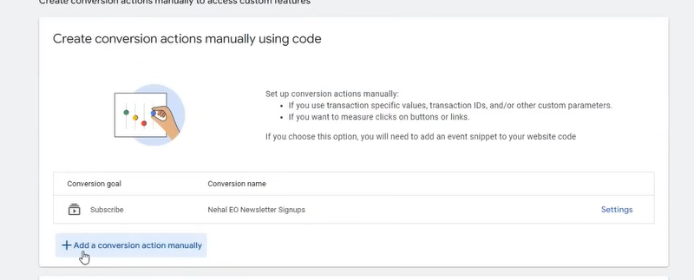

Now our manual conversion action is formed as shown above

Now we make another by clicking on where the pointer is in above image

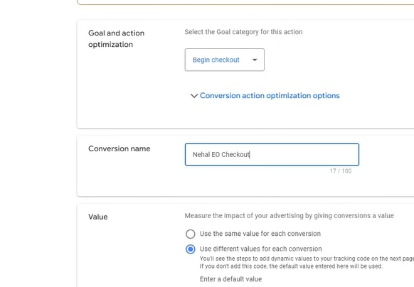

This time we choose Begin Checkout instead of subscribe this time

We choose third option because there is no need value involved

In count we will choose one because how many times he do the checkout of the same product its has only one value

Click on done button

Now we will again make new conversion but this time choose cantact in subscription

We choose third option in value and in count choose one and then click on done button

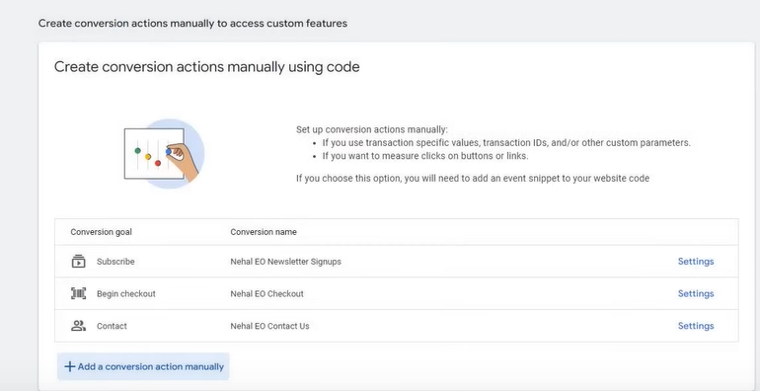

Now on above there are manual conversions

I think for every trigger in google tag manager we are making a conversion

So by comparing conversion to trigger in tag manager

Form submission remain and this time we choose Submit lead form and third option in value

And one in count

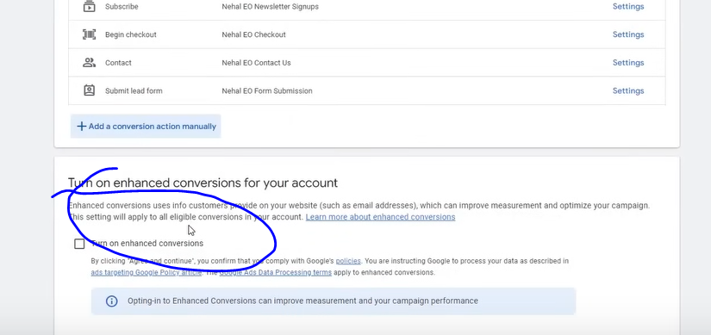

You will see an option as marked above

If you check the option turn on enhanced conversion then this will provide addition information to google ads(who knows)

It is optional but it can be mandatory in future so to read about it by clicking on the Learn More link beside the marked above

We click on save and continue

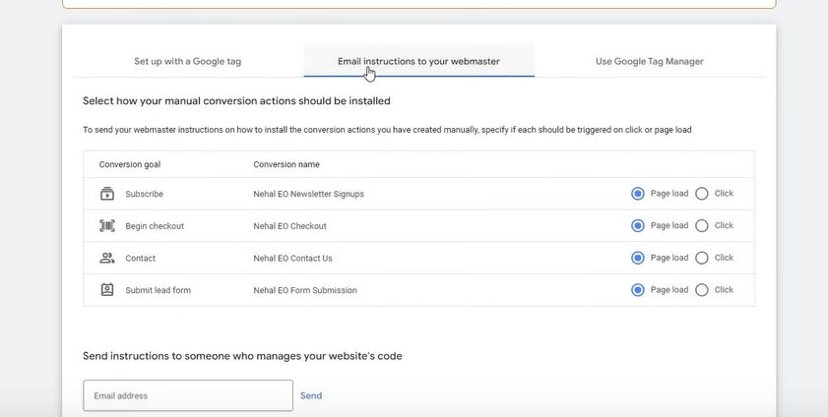

Now you will three tabs

If you choose first tab(Set up with a Google Tag manager ) then you have to out some thing In your website

If you choose the second tab(Email instruction to your webmaster ) then you can send instruction to your developer as email so he can develop it and make the conversion happens

Or you can choose third option(Use Google tag manager ) WE will use this option because we are using Google Tag Manager

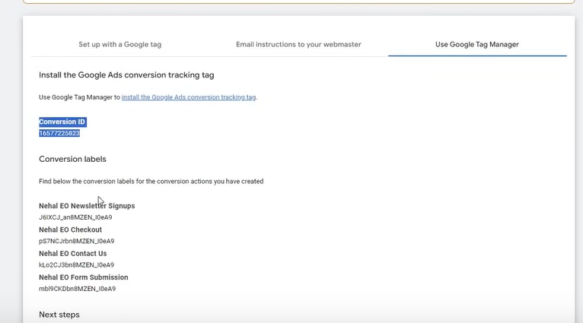

Now in google ads there is a conversion id given above as selected in our google ads

Every account has a unique Conversion id

But there are multiple conversion labels There are different conversion labels for different tracking

By this it is decided which conversion should go where Now we need t submit them in Google Tag Manager and we need to set triggers on these conversion labels

Now we go to tags sidemenu in the Google tag manger

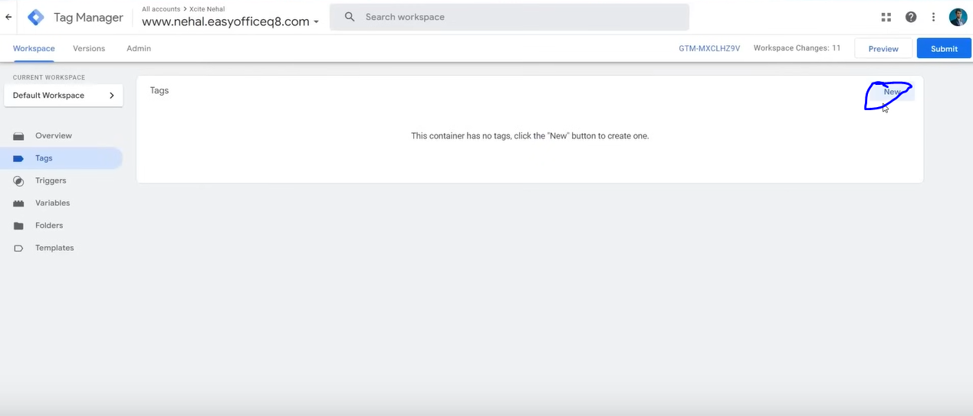

And now click on new as marked above to create a new tag

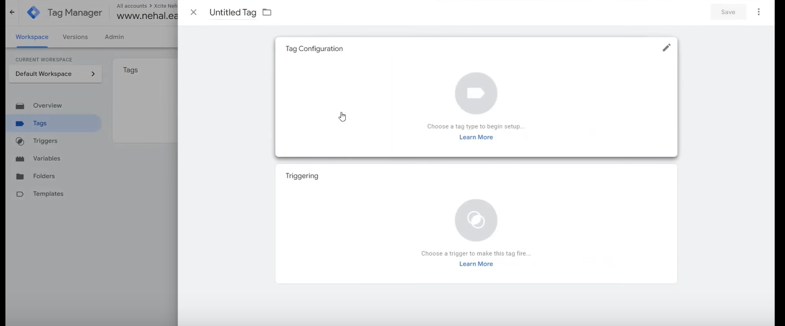

Click on Tag Configuration

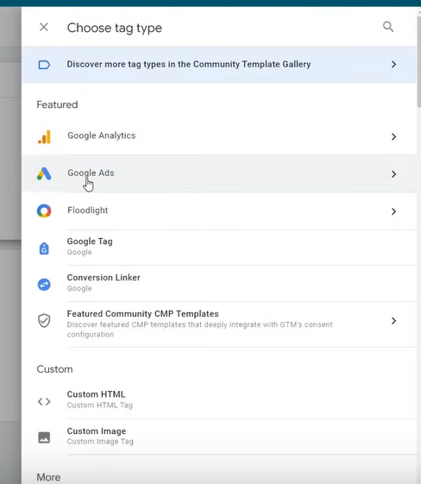

Now click on Google Ads

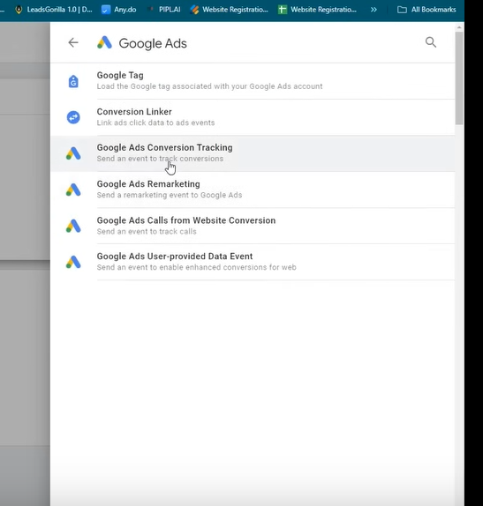

And since we are tracking Google ads conversion Tracking

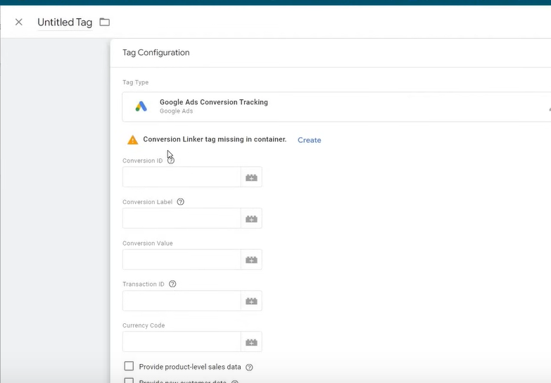

Now it will give you initially warning that linker tag is missing in container

So click on create beside it

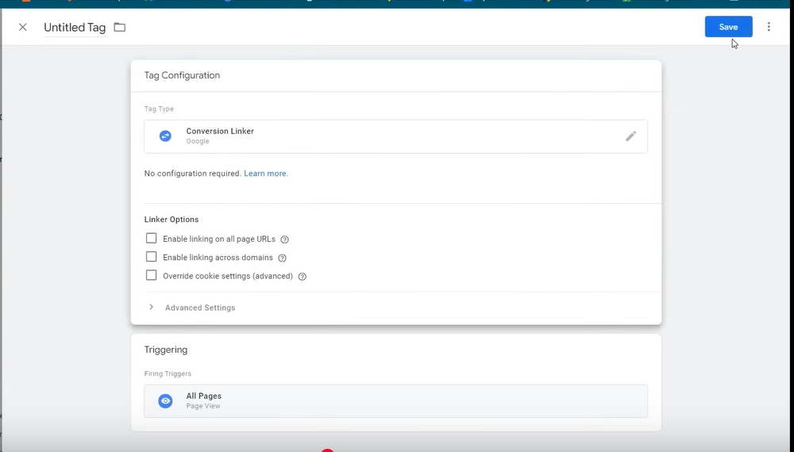

An save it as it is It will do all the configuration by default

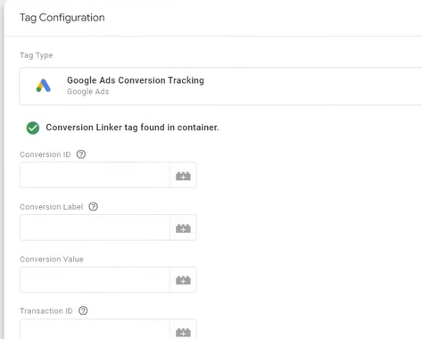

Now it is fixed as shown above

Now as you can see the field above of conversion id , conversion label,

Paste tehm by copying it from google ads from shown below



Name the tag same as its respective manual conversion name

We have connected it but we have to assign trigger to it which tell on which trigger the conversion tracking should be fired

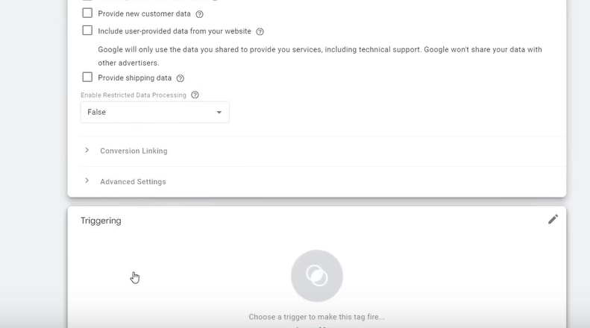

So click on triggering as shown above

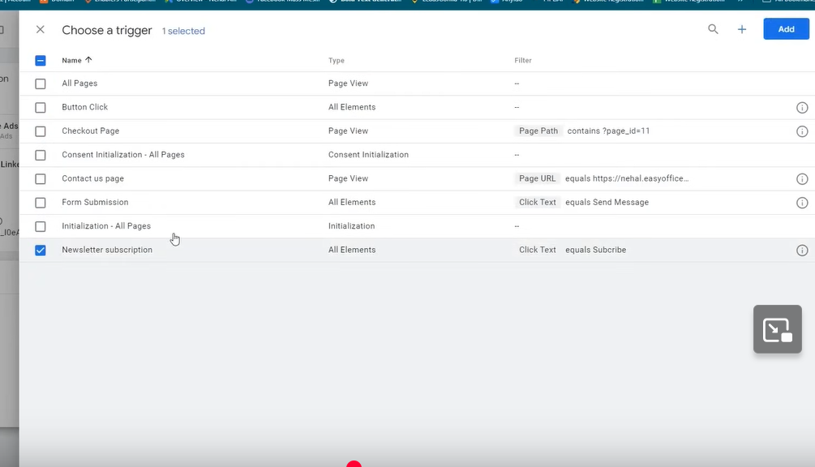

Now assign the conversion to its trigger by checking the checkbox related to that trigger

Sice we are setting conversion for Newsletter subscription we chose Newsletter trigger

Now click on add

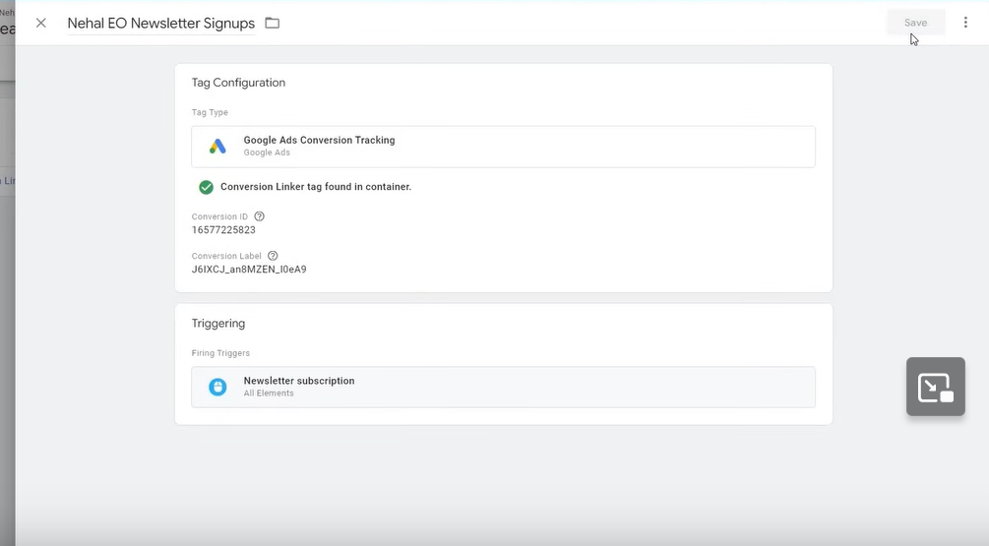

Click on Save button

First we have done it

You don’t have to add conversion linker tag again and again

Now we will link the trigger to their respective conversion

**Phase 24**

We will do for checkout

Now we do for contact us

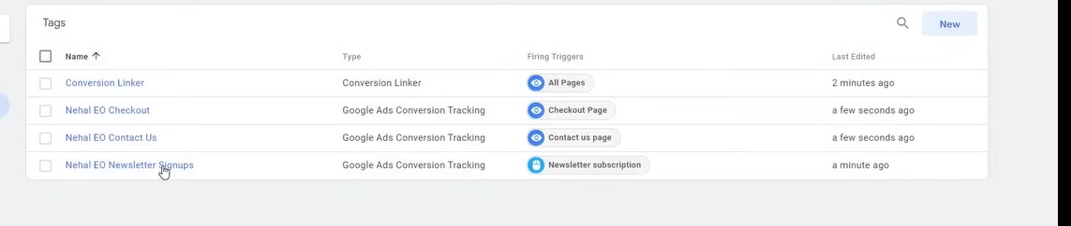

Now suppose in one tag multiple type conversion is happening for example

If we are making a lead tag then inside lad we have form submission or calls then we can assign multiple trigger as marked below

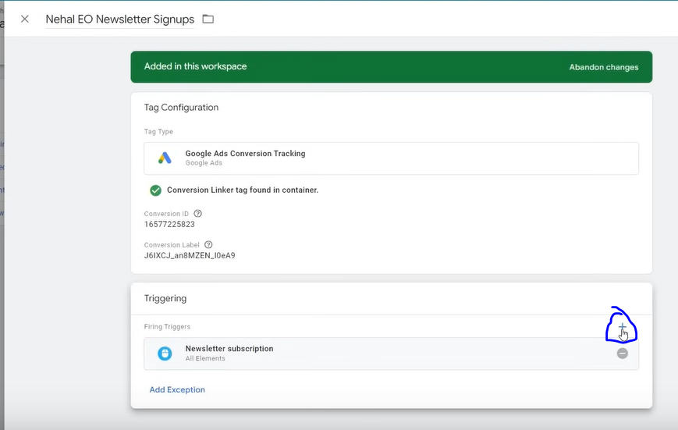

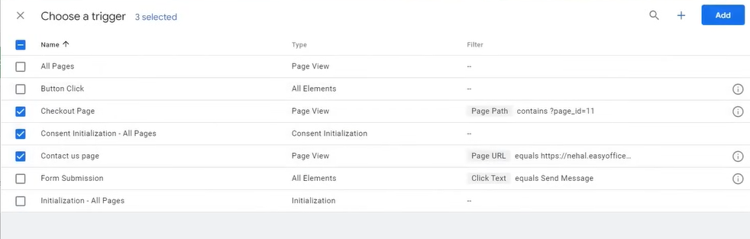

So whatever trigger happens in the selected ones then it will be considered that one conversion happened to which they are attached to

And Now we do form submission

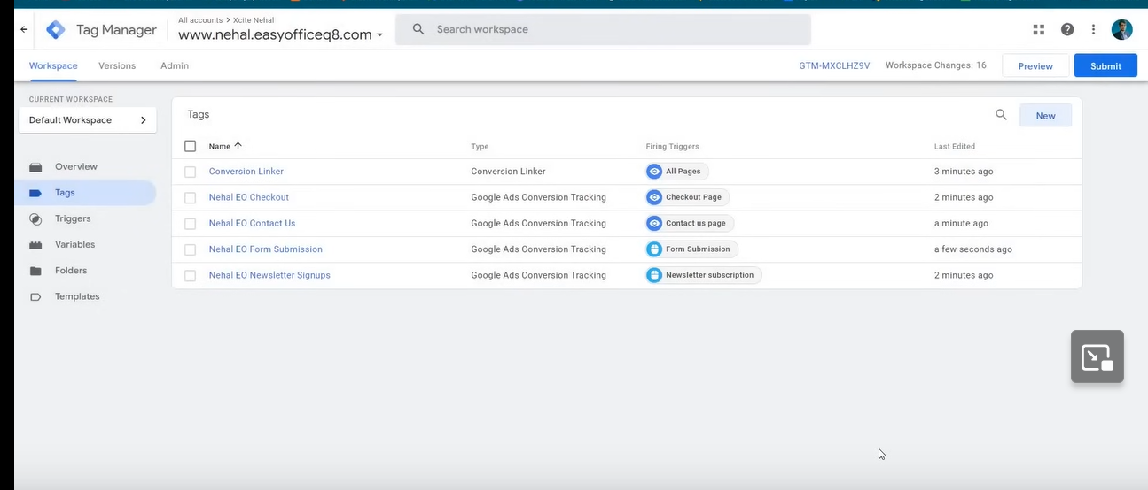

Now above all our tags are made

The work we do till now is drafted TO publish them in real world

Now to publish it click on top right corner part of the above screen

We go to overview sidemenu

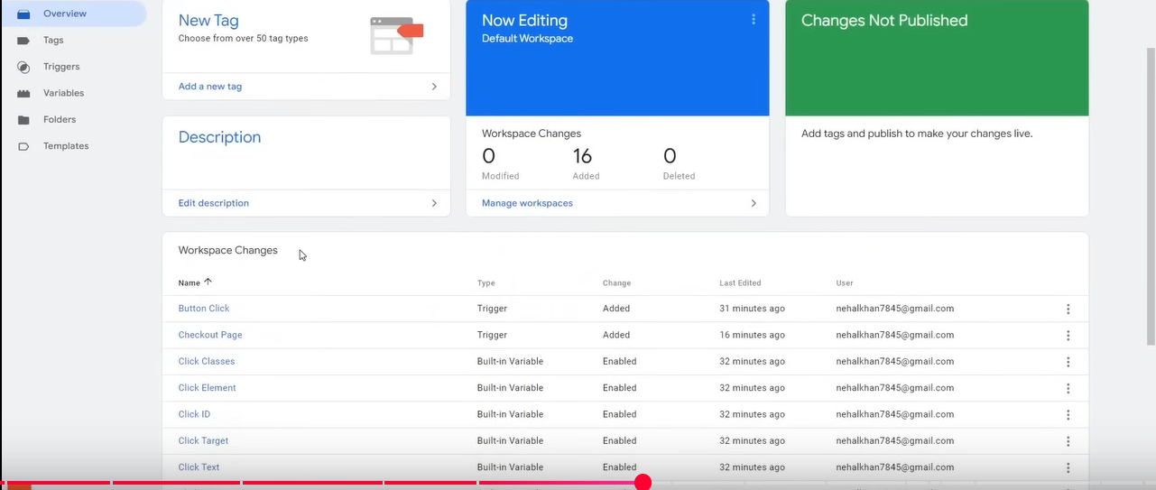

Now in workspace changes all changes will be shown that we have commited

Now in this list if there are zero changes (item )in the list then it means they are published

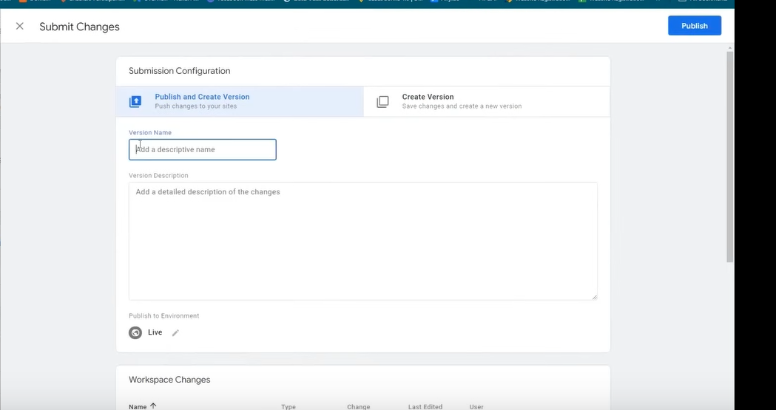

Now click on submit in top right corner now that above screen will be shown

Nnow you can name this a version name Now click on publish button

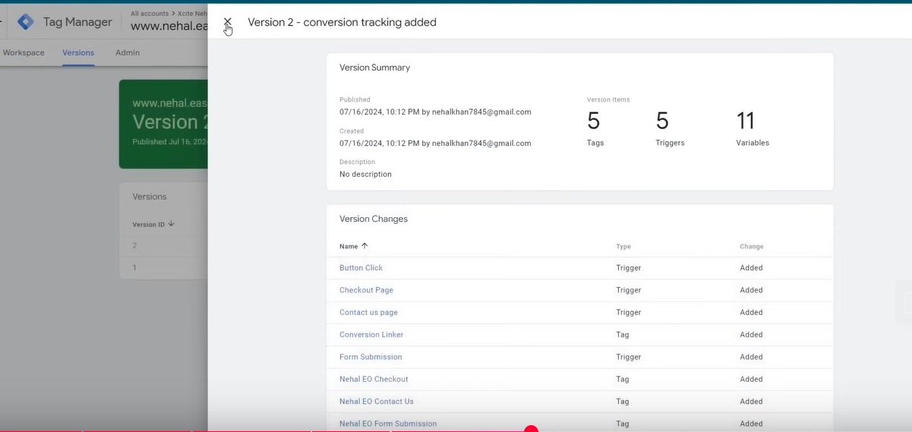

Now above screen will be shown in which the verision summaru is given (means the change we have commited)

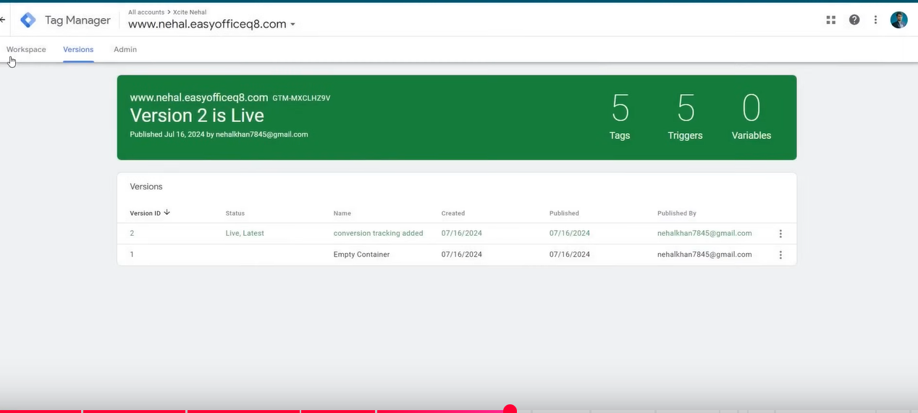

Now it will show your version is live that you have published

NOw go to Workspace tab to go to our Google ads UI

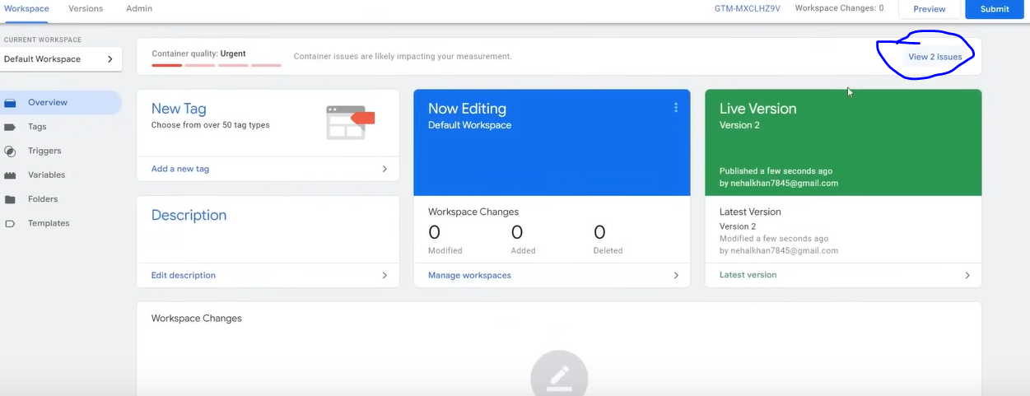

Now there may be some issues as marked above you can click on it to know about it

These are because we are using a demo version

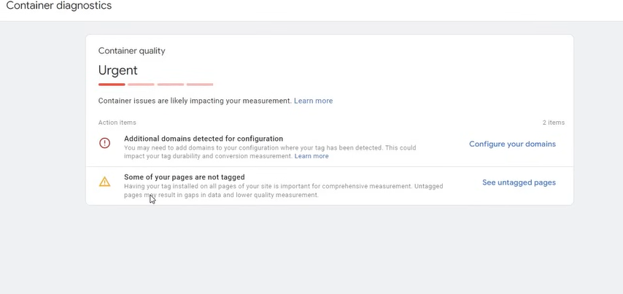

The error teacher get is above he is getting it because the secondary url is different from main domain

And some pages are not being traced by tag

Now we need to test are these trigger or tag are working or not